Analyse and design a MySQL C# based game. Prototype TSQL procedures for game functions. Revise and refactor the codebase and GUIs. Implement multiuser concurrency.

DAT602 Project

MySQL Game

13/11/2024

Jayden Houghton – 13524050

Contents

Design (Milestone 1) 2

Game Description 2

Graphical Design 4

Logical ERD 11

CRUD Table 13

DDL SQL 16

Prototype Application 21

SQL Procedures (Milestone 2) 25

Design Notes 25

Login Procedure 26

Registration Procedure 30

Layout Procedure 32

Generate Map (Place Items) Procedure 36

Player Movement Procedure 40

Update Score Procedure 44

Interact (Pickup) Procedure 46

NPC Movement Procedure 50

Stop Game Procedure 54

New Player Procedure 57

Update Player Procedure 59

Delete Player Procedure 62

Multiuser Concurrency (Milestone 3) 65

Concurrency Refactoring 65

Error & Exception Handling 66

Concurrency Management Comparison 70

Changes 72

References 73

# Design (Milestone 1)

## Game Description

**Concept**

Survivor Island is a 2D point-and-click style game. Two or more players can verse each other, racing to collect items and stay alive the longest. Plays can click on tiles to move around the 2D tile map. The island is covered in an assortment of items, including food to heal health, treasure to increase the score. Fighting animals will award score points but reduce health.

**Items**

Once on a tile with an item, players can click again on the tile to interact with the item. Food items will be added to the players inventory and treasure items will be instantly converted to score. Items are spawned at random empty tiles throughout the game.

Picked up items are added to the inventory and stacked in designated slots, while treasure is automatically converted to score. Use buttons will use the related item and apply its effect.

|  |  |  |
| --- | --- | --- |
| Item | Type | Effect |
| Fruit | Food | Health +20 |
| Meat | Food | Health +50 |
| Coin | Treasure | Score +1 |
| Gem | Treasure | Score +5 |

**Hunting**

NPC animals will spawn at random tiles around the map. Moving to a tile with a creature and clicking the tile again will trigger the fight calculation. Successfully hunting an animal will award score points. Animals will wander randomly around the map with a simple algorithm.

|  |  |
| --- | --- |
| Animal | Effect |
| Spider | Health -10, Score +5 |
| Snake | Health -30, Score +10 |
| Boar | Health -80, Score +20 |

**Scoring and Winning**

Score points are gained through picking up treasure and hunting animals. The game ends when there are no items and animals left (as there is no way to gain score). The player with the highest score wins!

**Accounts**

Players can login to their personal account. If the account does not exist, it will automatically be created. Accounts can be banned by admins and will be locked if a user fails too many login attempts. Accounts store basic information about the player and all of their characters. Accounts can be deleted by the player.

**Admins**

Some accounts will have admin abilities. This includes killing running games, adding new players, updating existing player’s data, deleting player accounts and banning an account.

**Map**

The map is composed of 2d tiles, that may have other items, animals or obstacles placed on top. The map and item placement will be randomly generated. Player’s move by clicking on an adjacent tile (no diagonal). Some tiles will be filled with obstacles (e.g. rocks) which the player cannot move to.

**Lobby and Games**

Once signed in, each player will be able to see a list of all other online players and their highest score. Player’s can click on another player to send a game request. If the other player accepts, a new game is started.

**Chat**

Each game has its own text chat where players can message each other.

## Graphical Design

**Login and Register**

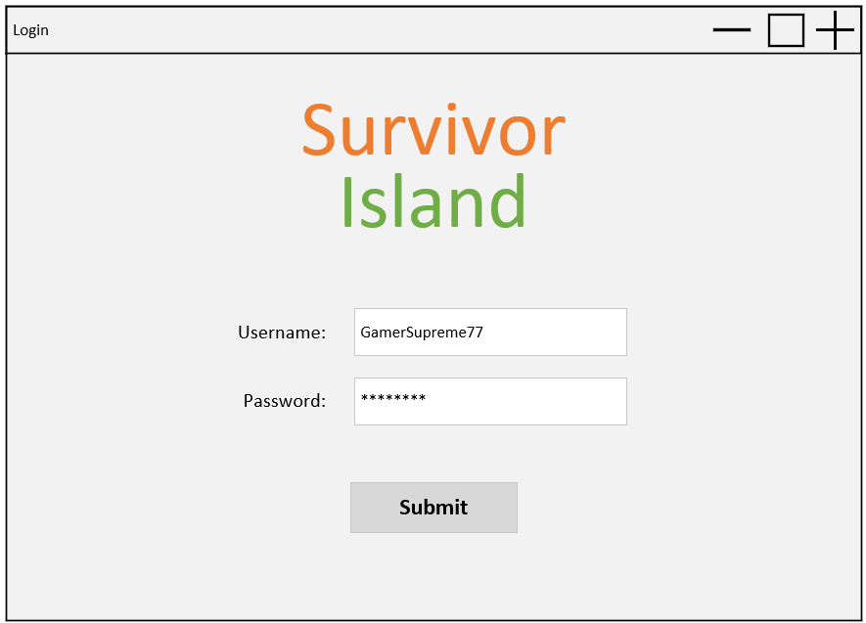

3

2

1

*The user loads up the game, entering their username and password, then clicking the submit button to login. New players enter the username and password they want to set for their account.*

1. Username is used for login and also how the player is named in the game.
2. Password is hidden for security.
3. Submit attempts to login the user.
   1. If the username is found but password is incorrect, display login failed popup (below).
   2. If username not found, display register popup (below). If clicked yes, go to lobby and create new account in database.
   3. If account is locked, display locked account. Account will be locked if 5 failed login attempts are made.

*The user entered incorrect login details.*

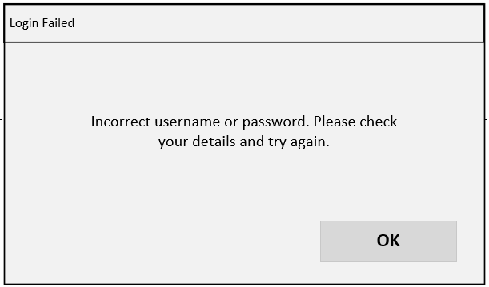

*The username does not exist, so a new user is being made.*

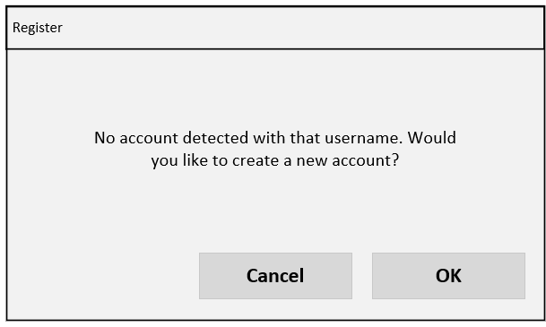

*The user has inputted incorrect passwords too many times and has been locked out.*

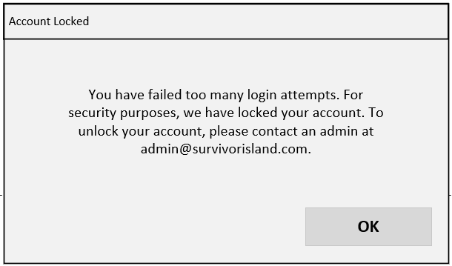

**Lobby**

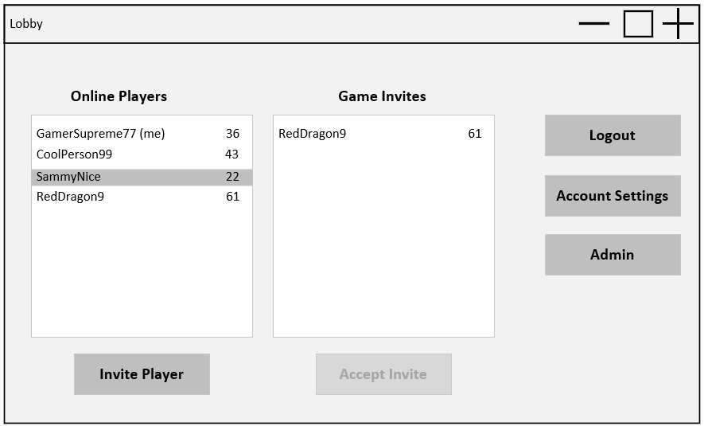

7

6

5

4

3

2

1

*The user has successfully logged on. Selecting the online player SammyNice from the Online Players list, the user clicks invite player. SammyNice will receive a game invite from the user, which will be listed user Game Invites. If SammyNice selects the game invite and clicks Accept Invite, the game will begin.*

*After playing a game, the user clicks Account Settings to update their password.*

*After updating their password and returning to the lobby. The user clicks Logout to log out and return to the login screen.*

1. Shows all currently online players with their highest score.
2. Select a player in the list then click invite player to send a game invite.
3. Shows all players that have invited you to a game.
4. Select an invite and click accept invite to begin a game.
5. Logs out and opens login page.
6. Opens account settings page with player data.
7. Only visible for accounts with admin. Opens admin window.

**Account Settings**

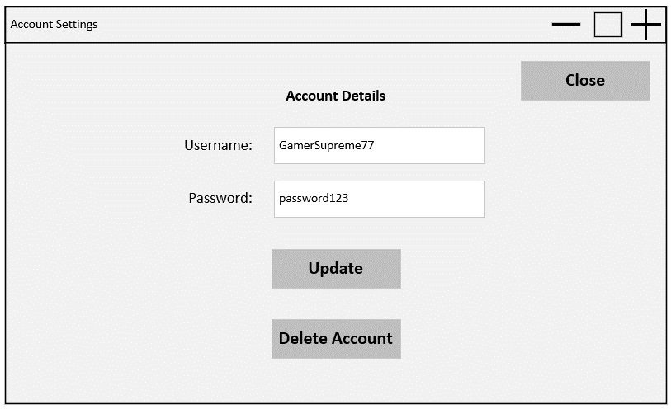

2

1

*The user wants to update their password. They replace the current password with their new password, click update, then click the close button to close the window and return to lobby.*

1. Updates the player info in the database.
2. Opens delete account confirmation popup. Accepting opens the login page and removes account from database.

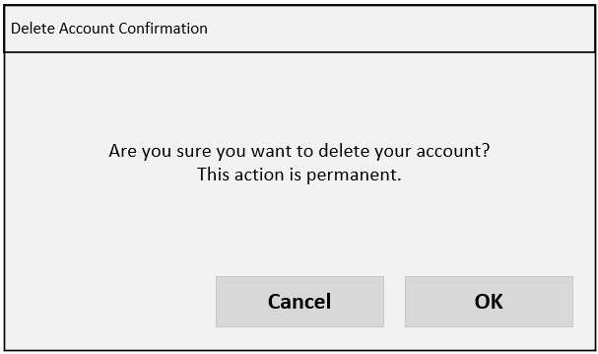

*The user clicks delete account in the account settings window then clicks OK to delete their account.*

**Admin Overview**

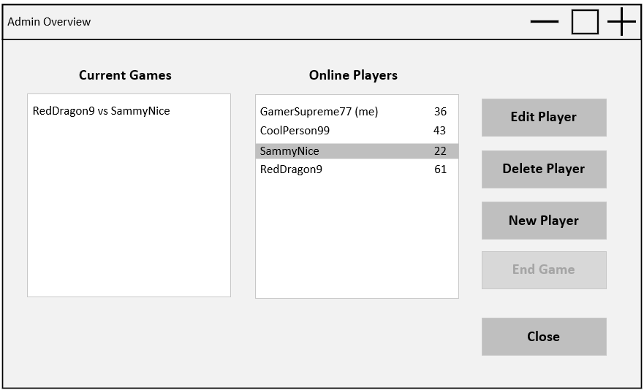

3

4

5

6

2

1

*After clicking Admin in the lobby, an admin user can view all online players, active games, and admin controls. Clicking edit player opens the account settings page (variant of above account settings page), where the admin user changes their password, unlocks their account, and saves changes, allowing a locked-out player to log in.*

1. Shows all current active games.
2. Shows all online players.
3. Selecting an online player and clicking edit player, opens up the account settings page (variant of above) with that player’s data.
4. Selecting a player and clicking delete player will open up the delete account confirmation popup. Clicking OK will delete this account.
5. Clicking new player will open up the make account screen (below). Clicking make account will create the account in the database.
6. Selecting an active game and clicking end game will stop and delete the game.

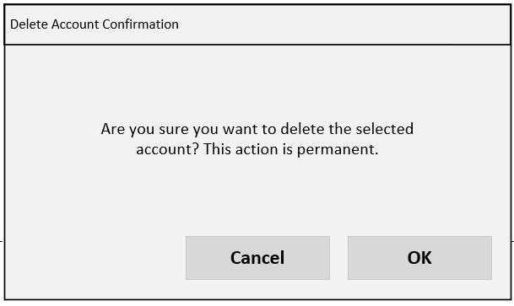

*Admin user selects an online account, clicks delete account, then clicks OK to delete user.*

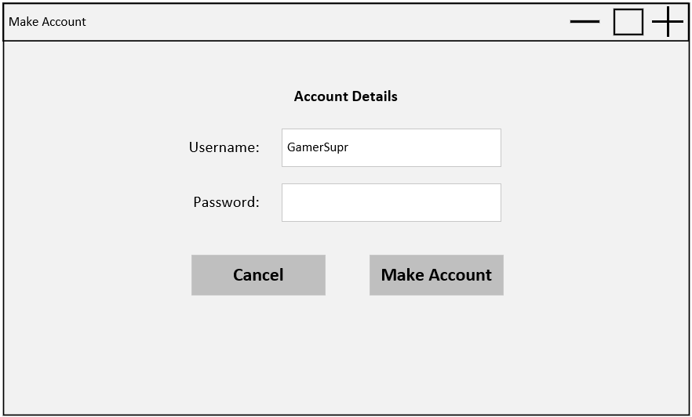

*Admin clicks New Player from the admin page, enters username and password, then clicks Make Account to make the new user.*

**Game**

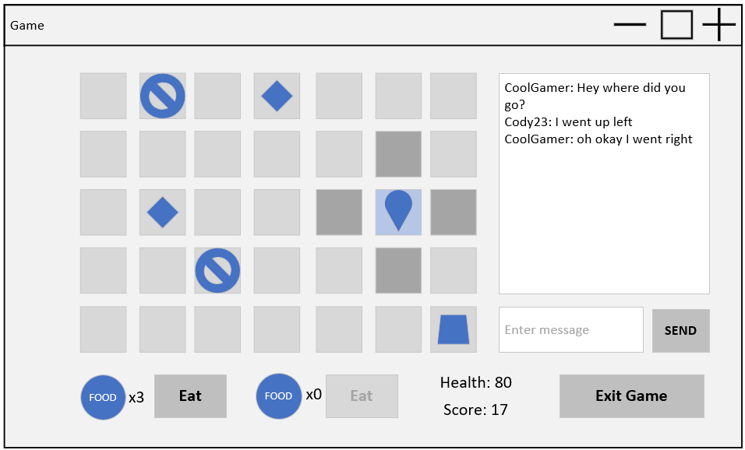

9

3

8

7

6

5

4

2

d

c

b

a

*The player clicks on adjacent tiles to move their character until they are on top of an item (e.g. gem). The player clicks the time again to pick up the item, which processes the items effects, in this case increasing score and setting the time to blank. The player moves again by clicking adjacent tiles until they are on the same time as an animal (e.g. snake). The animal moves to adjacent tiles at random intervals. Once on the same tile, clicking the tile again ‘hunts’ the snake, reducing the user’s health, increasing score and changing to a blank tile. The player clicks on adjacent tiles again to move across the board to a food item (e.g. fruit). Once on the time, the player clicks again to pick up the item, which is added to their inventory (shown bottom left of the screen). The player clicks the eat button nest to the related food item, increasing their health and reducing the quantity of that item in the inventory by one. The player then clicks on the chat message box, types out a message and clicks Send. This displays the message in the chat log, which all players in the game can see.*

Items are randomly placed when the board is loaded. The player starts on the home tile (1,1).

1. Items are randomly placed when the board is loaded. Mock-up key:
   1. Player
   2. Obstacle
   3. Item
   4. Animal
2. Exits the game back to lobby
3. Score is increased when collecting treasure or hunting. Highest score at the end of the game wins.
4. If at least one food item of the respective type is in the inventory, clicking eat will use it and apply its affects (only two food types).
5. Clicking an adjacent valid tile will move the player to that position. Valid means no player (however items or animals are excluded).
6. Animals (NPCs)
   1. When standing on a title with an animal or item, clicking the tile again will hunt the animal or pickup the item, applying the related effects to health, score and inventory.
   2. Animals will randomly move to adjacent times at intervals. This will not be GUI triggered by triggered every X time/game loops (e.g. every 5 seconds).
7. Recent chats by players in the game are displayed here
8. Any typed message will be displayed in the chat.
9. Displays health which is affected by hunting animals (reduces) or eating food (increases).

## Logical ERD

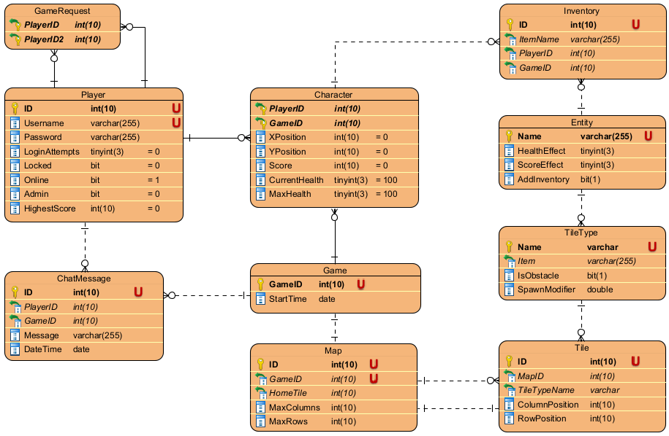

|  |  |
| --- | --- |
| Table | Explanation |
| Player | The player table represents each user account in the database. This table must include authorisation details for the account: username and password. I have decided to use username as the unique login identifier instead of an email as username also becomes the player name, covering both fields. Other attributes like login attempts and locked are needed for the login process to lock accounts after too many failed attempts. Online will display that user along with their highest score as an online player and available for new games. Admin gives access to an admin screen for player and game management. |
| Character | Characters represent the player in each specific game, and thus belong to a player and a game (also compound ID). This must store the position of the character in the map, their score, and health stats. Games and players can have many characters, but each character only has one player and one game. |
| Game | A game instance is how characters are connected in a game. A game can have many characters. |
| Map | Each game has one map, and each map has one game as it is hold the representation of the current state of animals and items and objects for that game. It must store the max size, as the map is randomly generated, as well as the ID of the home tile for resolving player conflicts. The map table could be combined with the game table, however I have not done this to separate concerns. |
| Tile | Tile holds every single tile instance in a map. Many tile instances belong to one map. One tile will also be referenced by map as the home tile. Each tile must store its position in the map, as well as the type of tile it is. |
| Tile Type | Tile type holds the different types of tiles that can be generated (coin, boar, rock, etc.). One type can be used by many tiles, but each tile can only have one type. The tile type will have a spawn modifier to create a rarity of more valuable items (i.e. higher score bonus from the item means rarer). Tile types may also be obstacles and block player movement (e.g. rocks). Tile types may link to items that are picked up or give effects when interacted with (e.g. coin gives score, fruit adds to inventory). |
| Entity | Entity represents collectible items and effects that are given by some tiles (e.g. coin gives score, fruit is added to inventory). Each entity stores a score effect and health effect, as well as whether it is collectible or not (add inventory). An entity can be used in one or more tile types. |
| Inventory | Inventory stores the collectible items a character has. There can be many inventory items of one entity type. This must hold the character’s ID (player id + game id), and the entity (item) name. Each character can have multiple inventory items but each item can only be owned by one character. |
| Chat Message | Chat messages represents messages sent in the in-game chat. Each message has a player id and game id so it can be displayed in the correct game. It also includes the message and the time sent. Players and games both can have many messages, but a message must only have one sender from one game. |
| Game Request | Game requests represents when one player has sent a request to another online player to start a game, thus has a many to many with the player table. A player may invite or be invited by many different players. |

Note: game requests are not directly linked to a game. Games are identified by the characters (and thus owning players) with each game, or a new game is made if an appropriate game is not found. For example, if a game request is between PlayerA and PlayerB, if the game exists, both players will have characters with the game game ID.

## CRUD Table

Key: C = Create, R = Read, U = Update, D = Delete

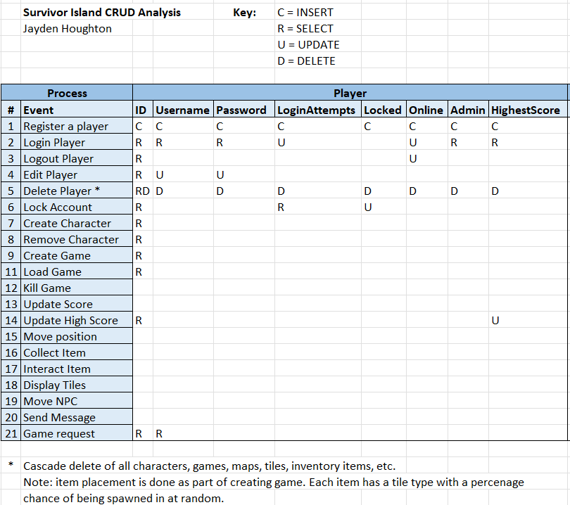

* Cascade delete of all characters, games, maps, tiles, inventory items, etc.

Hote: item placement is done as part of creating a game. Each item has a related tile type, which has a percentage of being spawned at random when generating the map.

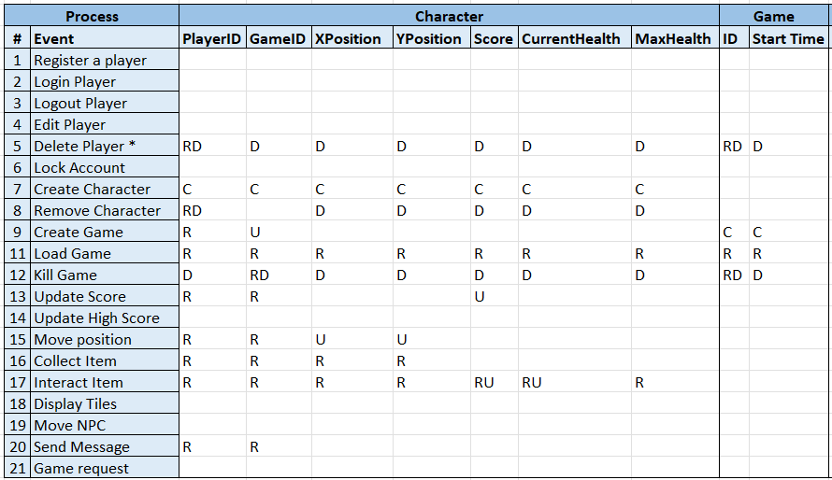

Note: Move NPC is included

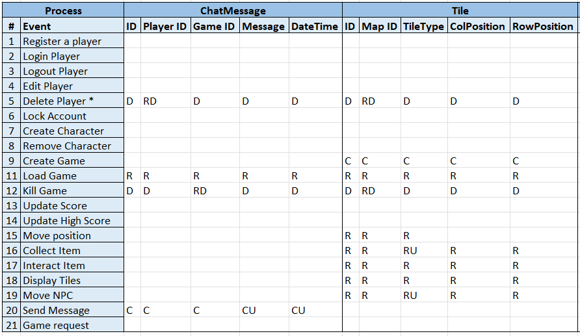

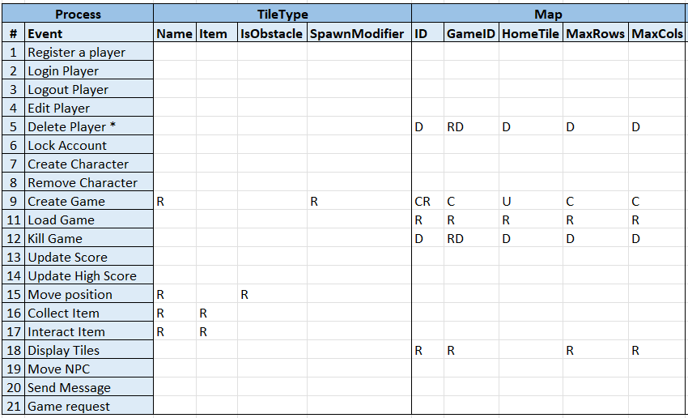

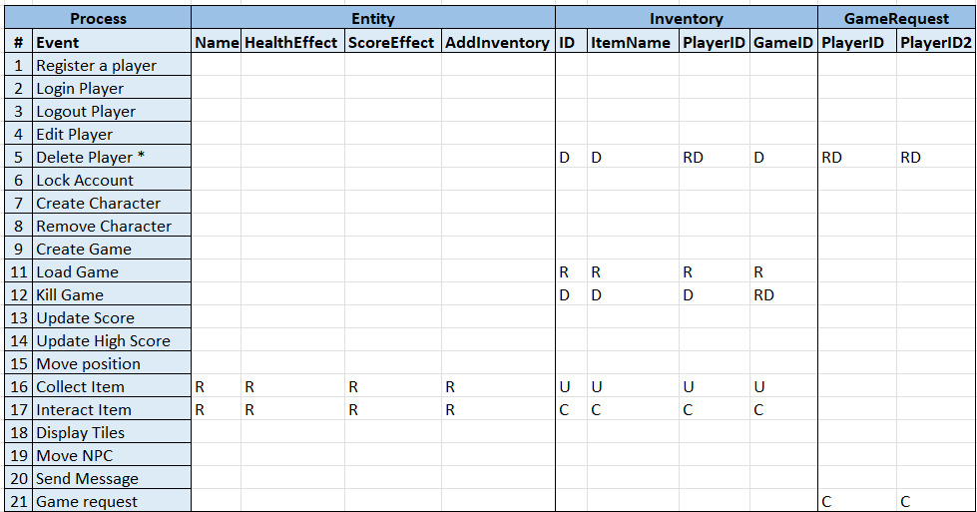

|  |  |
| --- | --- |
| Table | Description |
| Register a player | Create a new player record. |
| Login Player | Read player table. Update login attempts and online status. |
| Logout Player | Read player and update online status. |
| Edit Player | Read player and update detail attributes. |
| Delete Player | Read and delete player record, character records, game records, chat messages, tiles, maps, inventory and game requests. |
| Lock Account | Read player and update locked attribute. |
| Create Character | Read player and create character. |
| Remove Character | Read player. Read and delete character. Cascade delete games, maps, inventory, game requests, tiles. |
| Create Game | Read player, create game, character, map, tiles. |
| Load Game | Read player, character, chat messages, map, tile, inventory. |
| Kill Game | Read and delete game, map, tiles, inventory, characters, chat messages. |
| Update Score | Read character and update score attribute. |
| Update High Score | Read player and update highest score. |
| Move Position | Read tile and tile type to check if tile is obstacle. Read character and update position attributes. |
| Collect Item | Read tile and tile type for entity. Read entity. Create inventory item if entity add inventory attribute is true. |
| Interact Item | Read tile and tile type for entity. Read entity. If add inventory attribute is false, read score and health effects. Read character and update character score and health. |
| Display Tiles | Read map and tiles. |
| Move NPC | Read tile. Update tiles (animal -> empty, some empty -> animal). |
| Send Message | Read character, create chat message. |
| Game Request | Read player and create game request. |

## DDL SQL

**Start.sql**

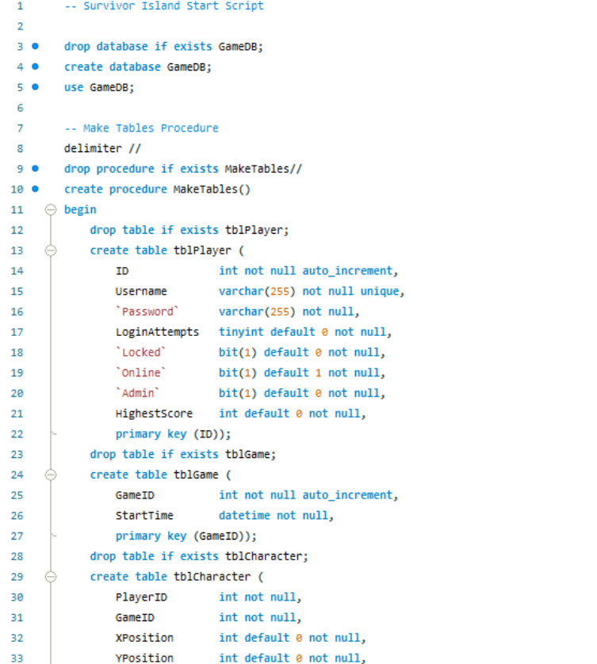

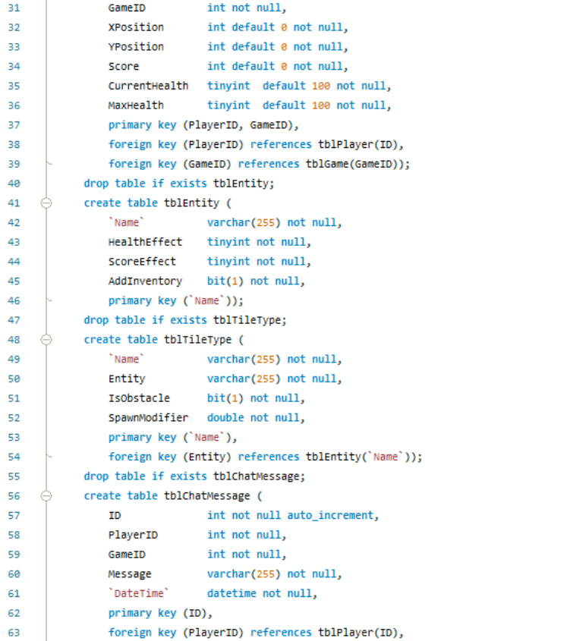



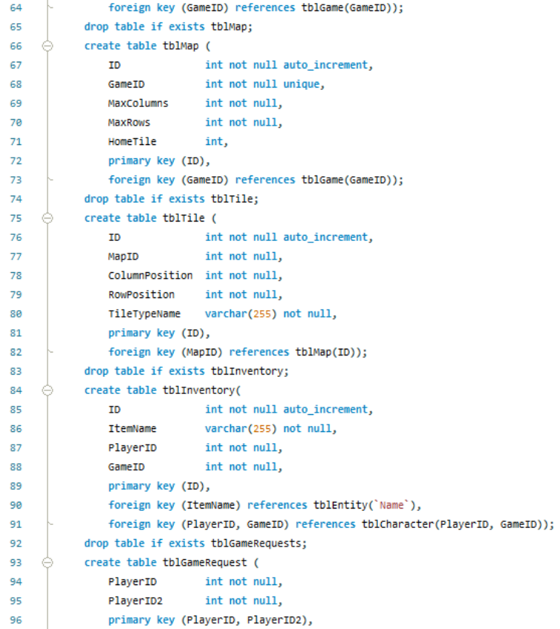

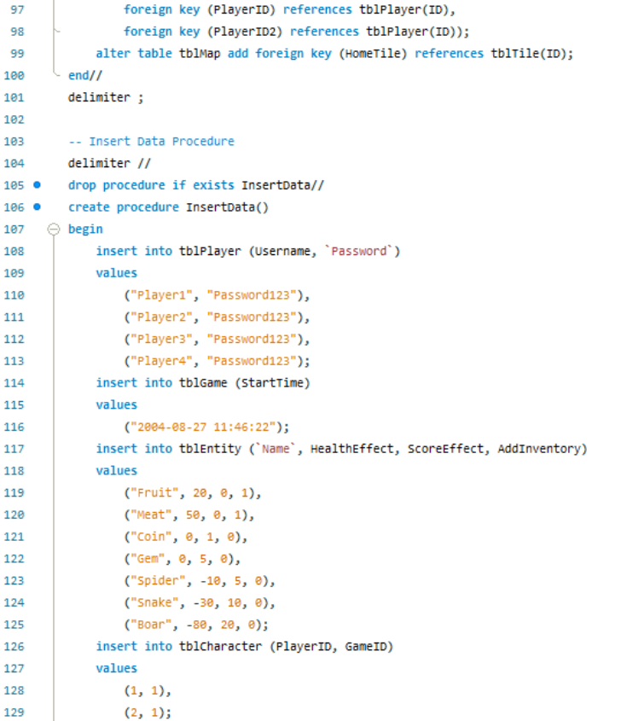

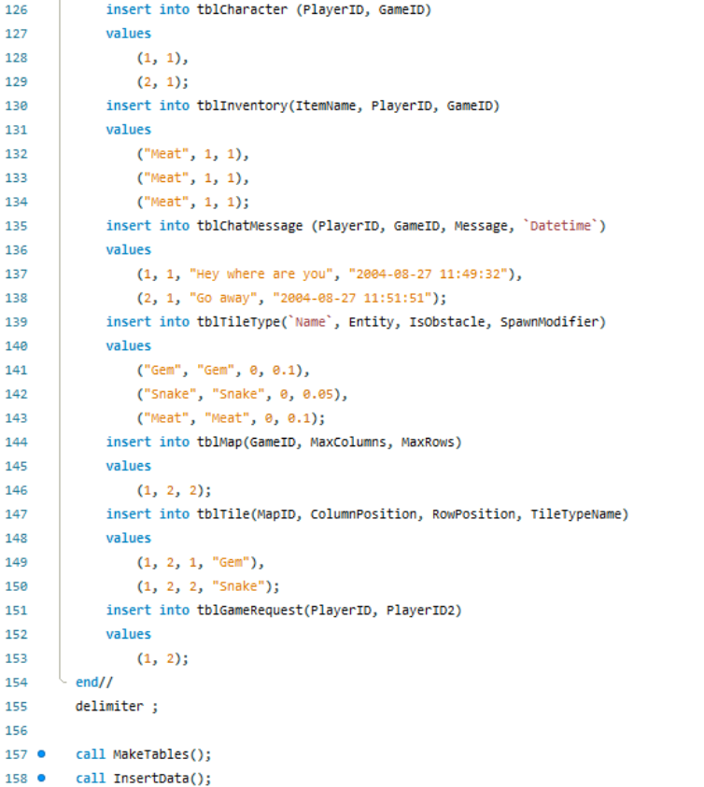



The script first creates and sets the database to GameDB. Next, all of the tables are created. Each table is dropped first to ensure that any changes are loaded by recreating all of the tables. Each table is created with a variety of attributes, each specifying a name, type and sometimes optional parameters. For examples *Username varchar(255) not null unique* creates a new attribute in the table called Username. Username holds variable characters like a string and up to 255 characters long. This attribute cannot be null and must be unique from all other usernames in the table. I have used backticks around some names to avoid conflicts with MySQL’s keywords. I have created almost all primary and foreign key constraints in the table creation. The second half of the script inserts base example data into each table for demonstration and testing purposes. The table creation and data insertion are encapsulated into their own procedures, which are called at the end of the script.

**Test_procedures.sql**

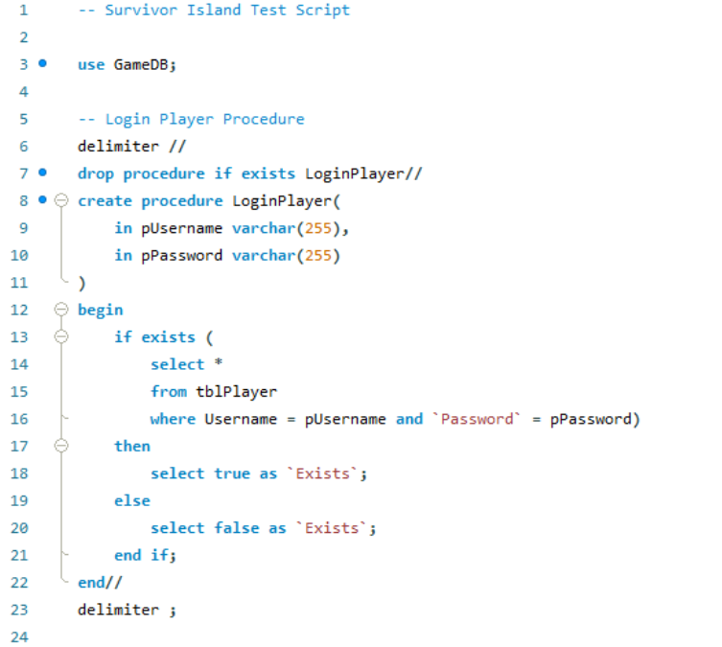

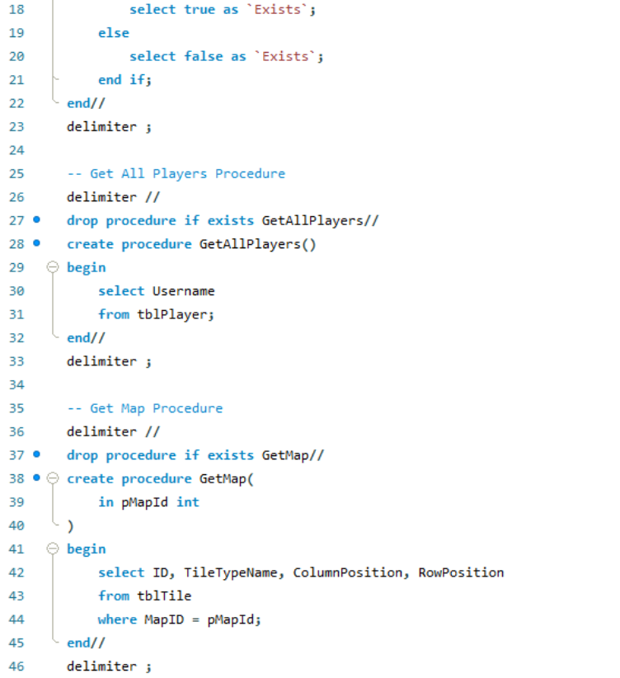

## Prototype Application

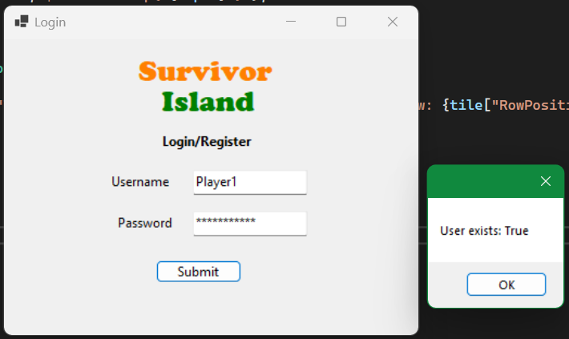

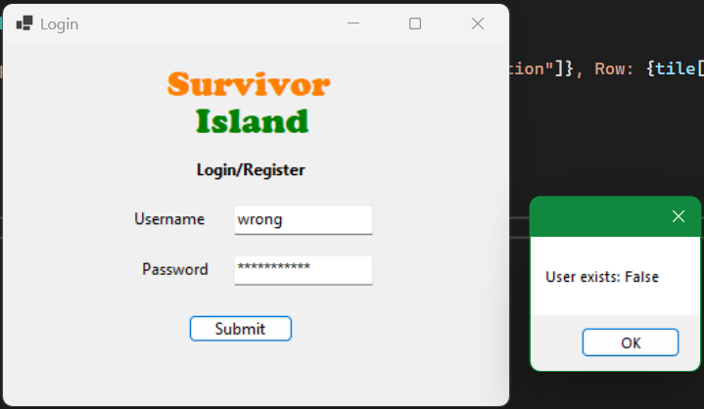

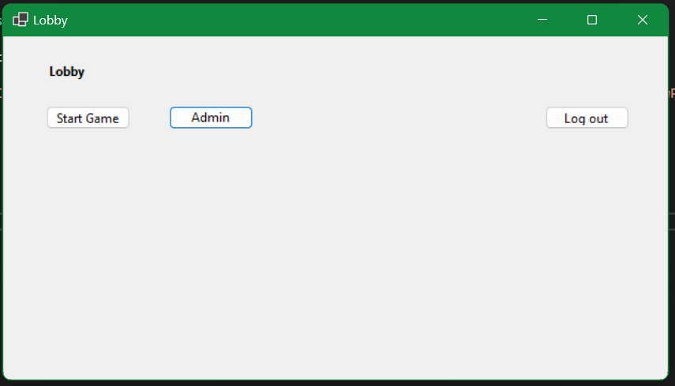

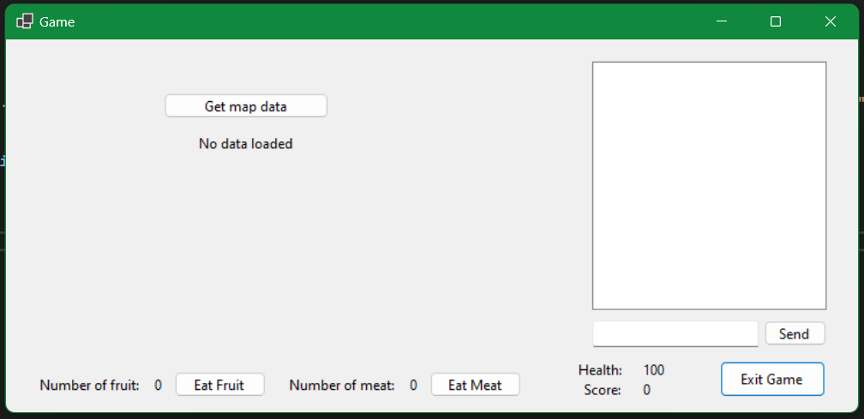

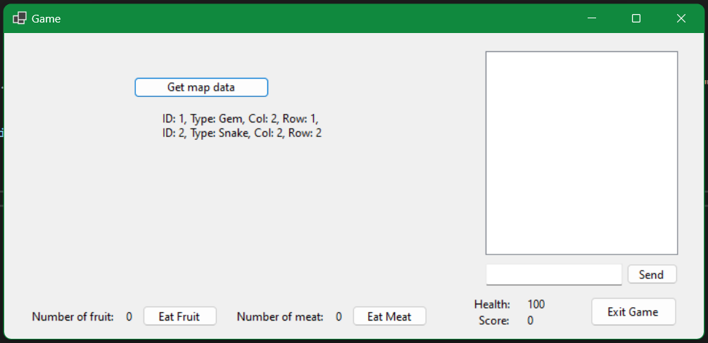

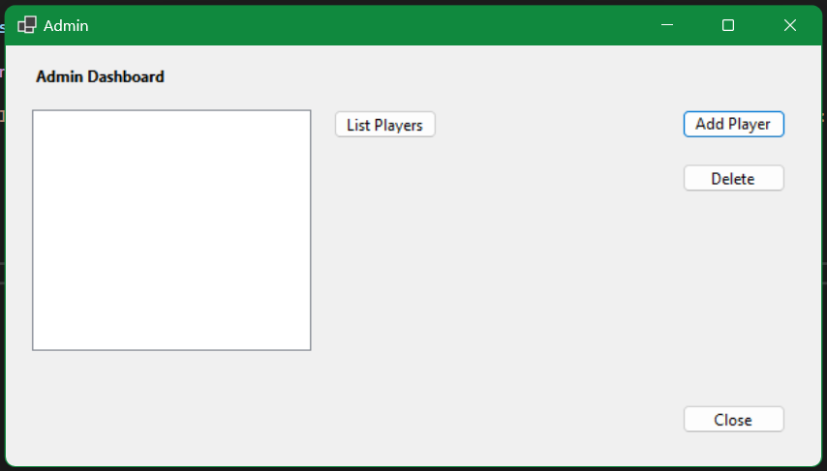

Note: input is the list box where admins can select players or games and click buttons to perform actions.

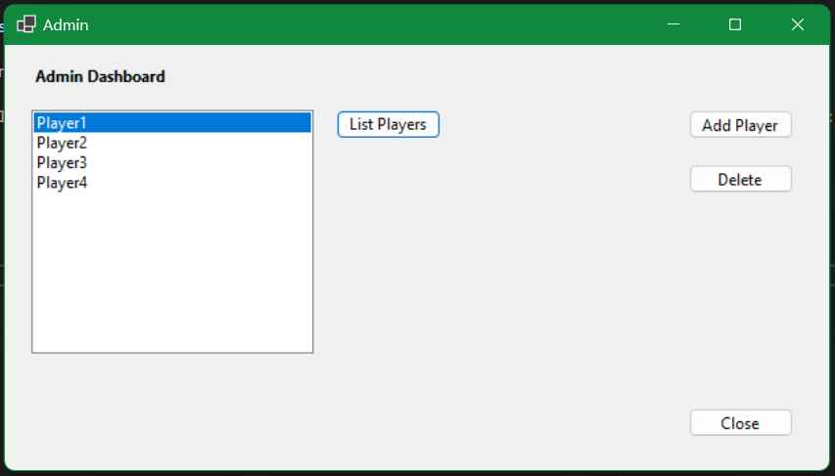

# SQL Procedures (Milestone 2)

## Design Notes

**Files**

* Please read the readme.md in the c# project for instructions on how to run the program.
* Please read the readme.md in the /db subfolder for instructions on the MySQL files.

Note: added ID to tblCharacter instead of using GameID and PlayerID as a composite key. This became quite complex to use in many queries and data rows, as CharacterID is used frequently, so I decided it was better to add a designated key.

**Draft Logic Flowchart**

For C# logic, procedure calling, procedure logic and database actions.

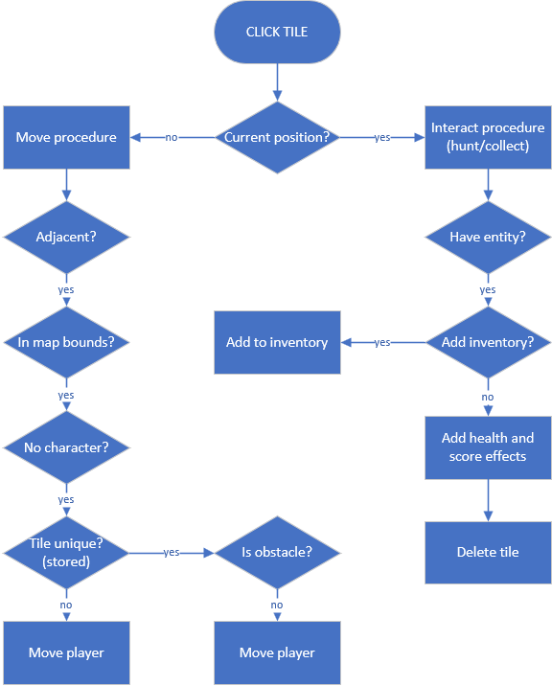

## Login Procedure

### MySQL Procedure

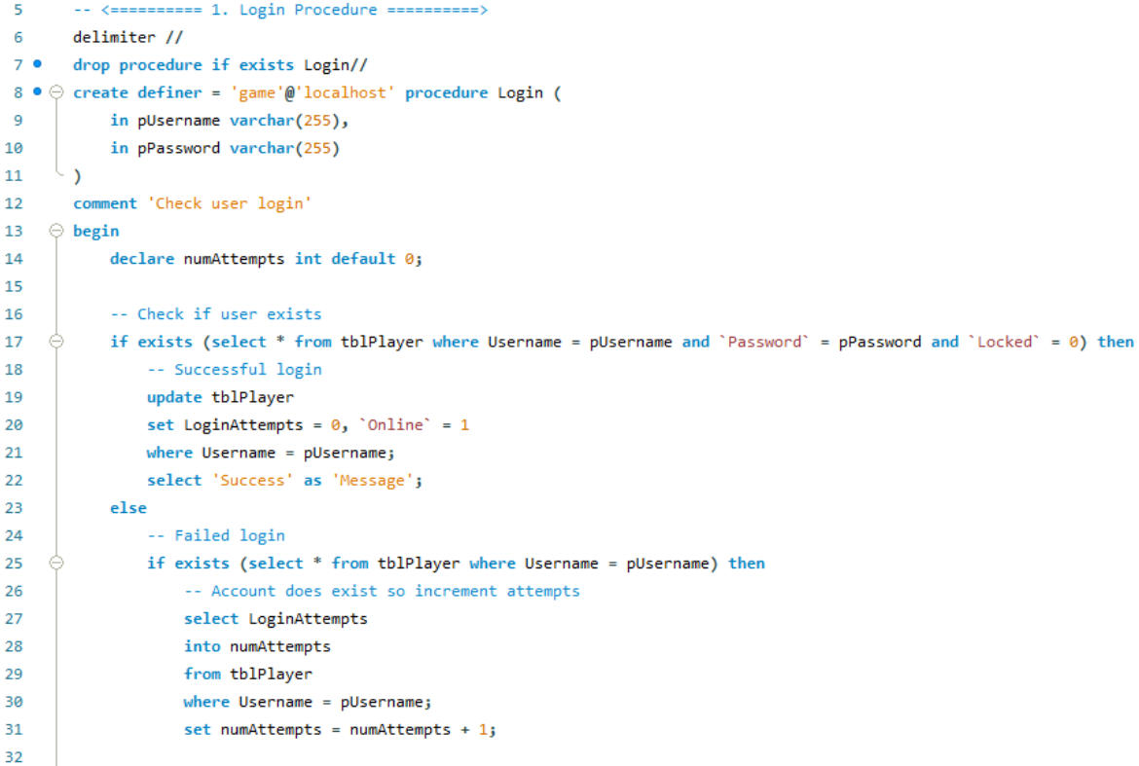

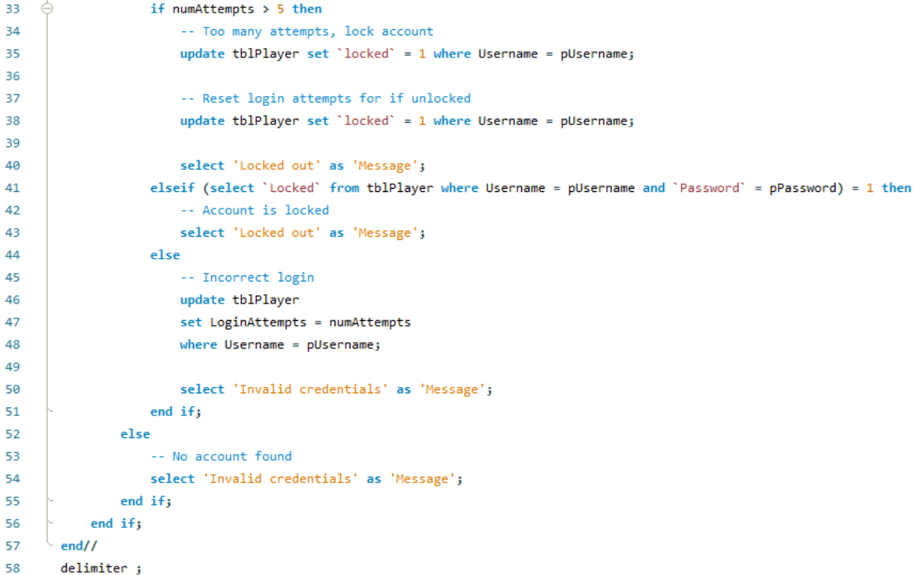

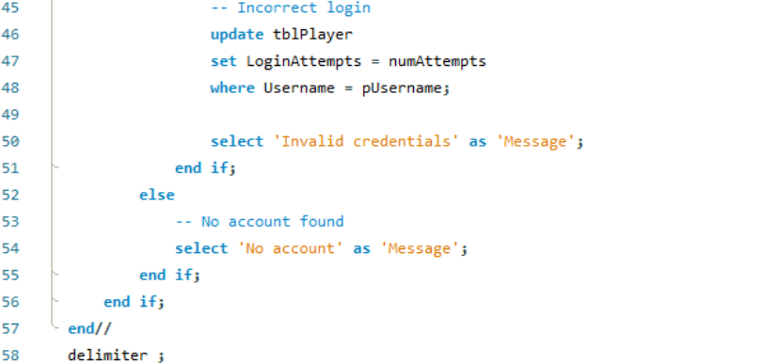

**Test Calls and Checks**

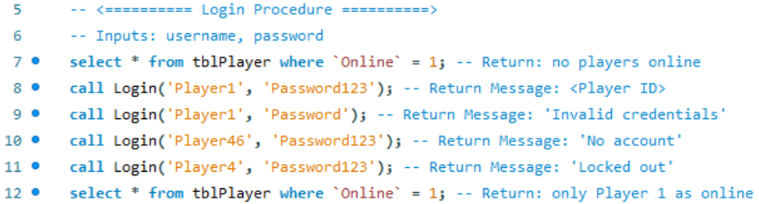

**Results**

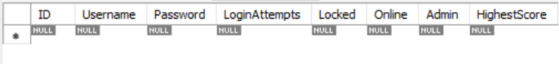

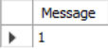 Player login (Player ID = 1)

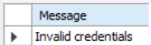 Invalid username or password

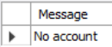 No matching username

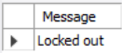 Too many failed login attempts

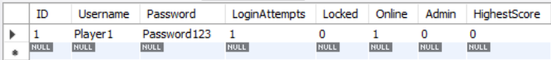

### C# Test

**DAO Method**

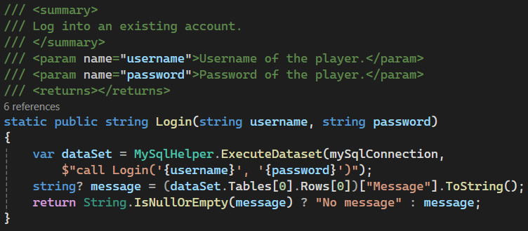

**Test Calls**

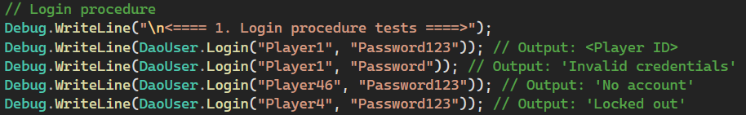

**Log Outputs**

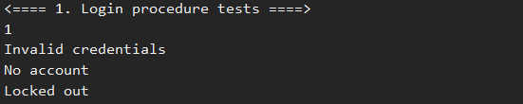

### GUI Implementation

When the login button is pressed, the inputs are collected and sent to the User DAO. If the login method returns a player ID, the lobby is loaded, else a switch statement handles the other possibilities.

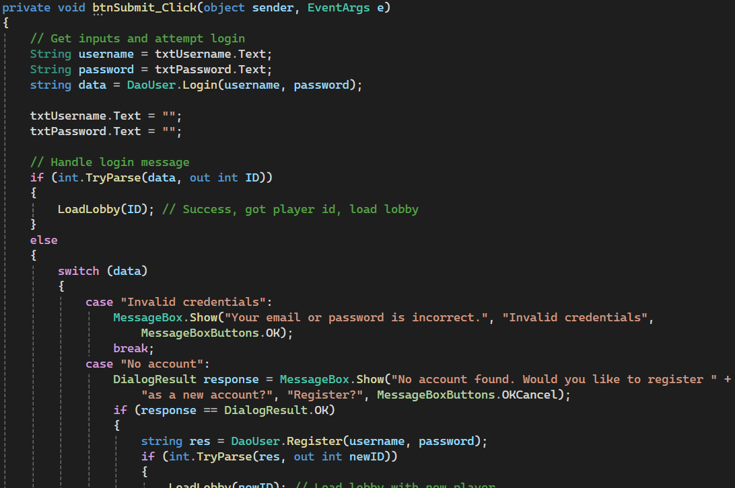

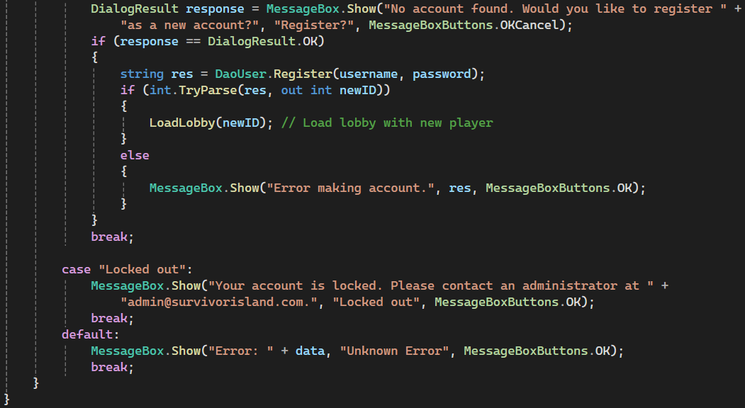



Successful login opens the lobby screen.

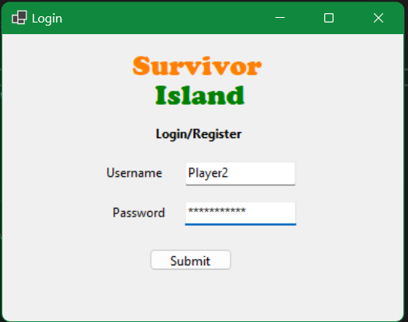 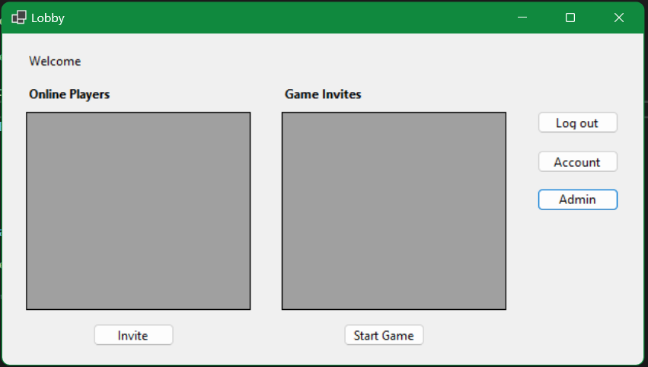

Incorrect password opens message pop up.

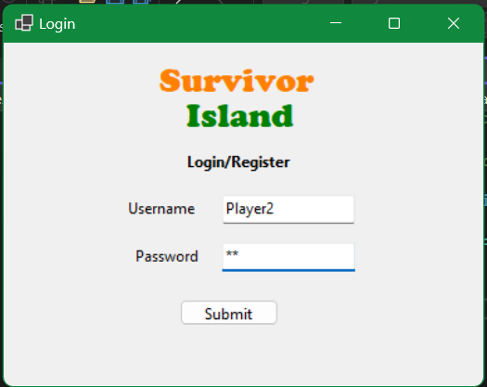 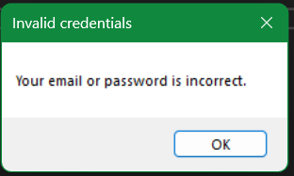

Attempting to log into a locked account gives locked out message.

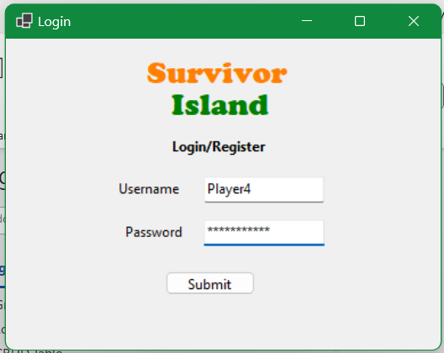 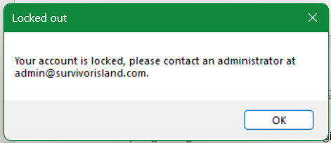

## Registration Procedure

### MySQL Procedure

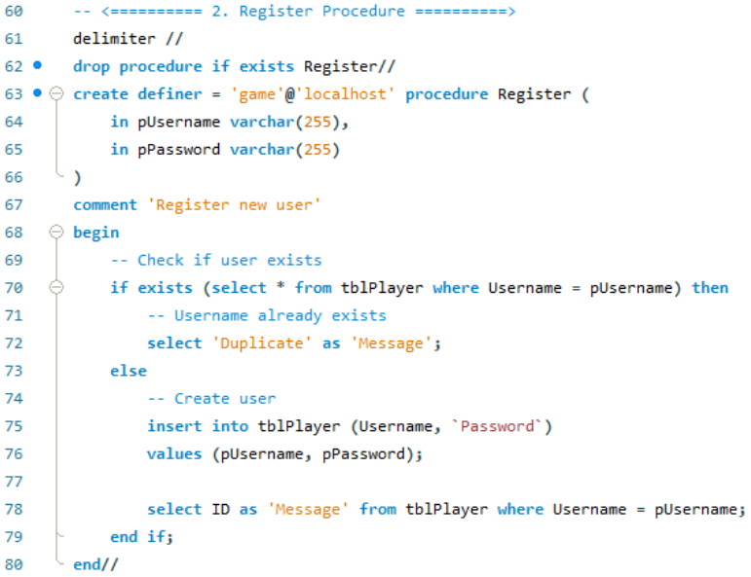

**Test Calls and Checks**

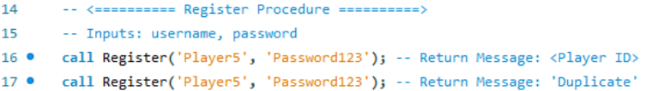

**Results**

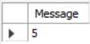 Register new user, returns player id

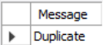 Using duplicate email

### C# Test

**DAO Methods**

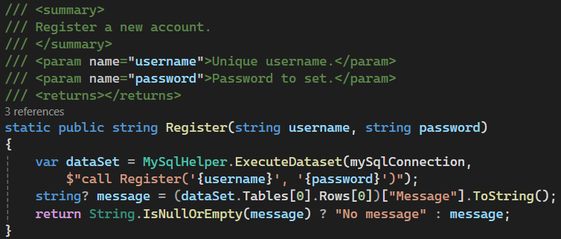

**Test Calls**

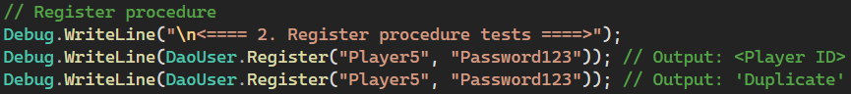

**Log Outputs**

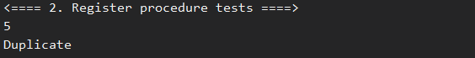

### GUI Implementation

As a part of the login process, if the login method comes back with “No account”, the user will be prompted if they want to make a new account. If they confirm, the account will be made, and the lobby will be loaded.

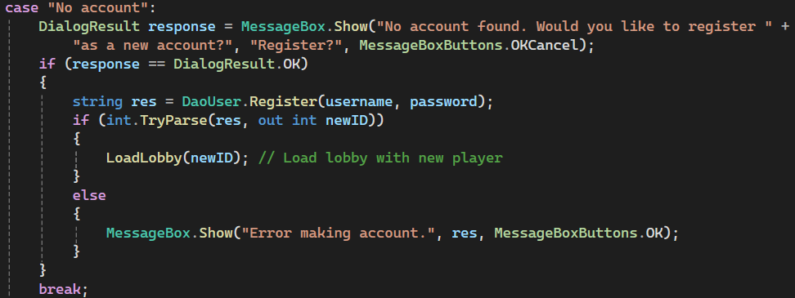

New unique username prompts registration, then opens lobby if accepted.

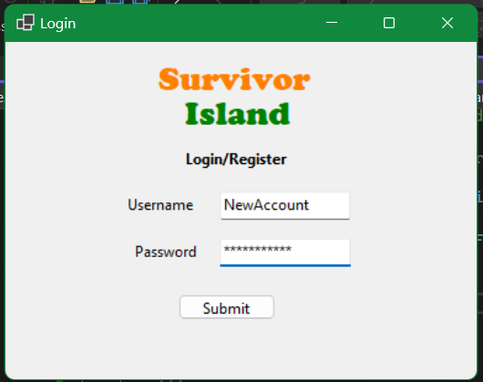 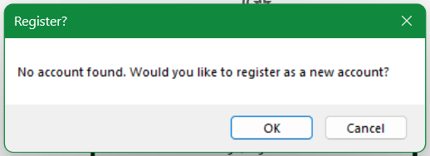

## Layout Procedure

### MySQL Procedure

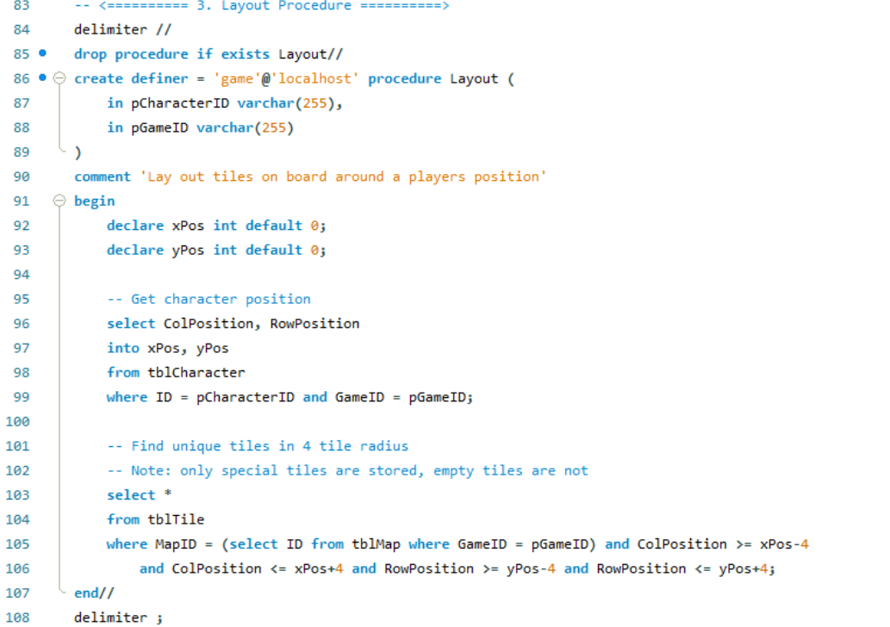

**Test Calls and Checks**

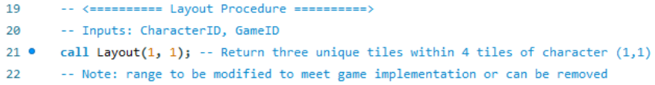

**Results**

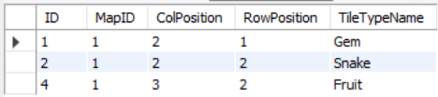

### C# Test

**DAO Method**

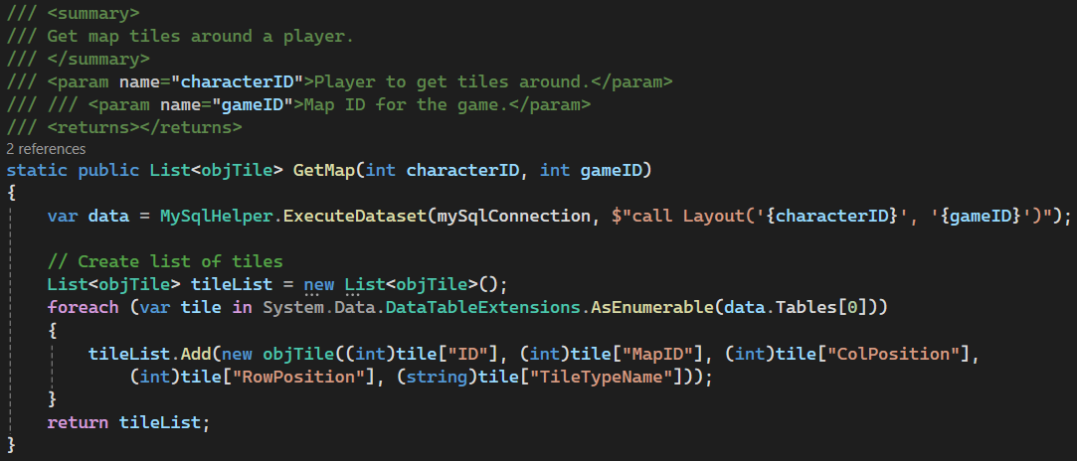

**Test Calls**

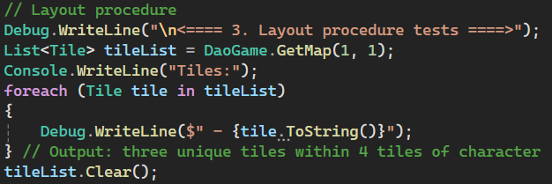

**Log Outputs**

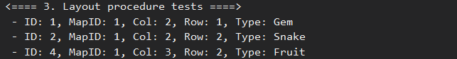

### GUI Implementation

When the start game button is pressed in the lobby, the game will check if there is an existing game with both player ids. If yes, the game will be loaded with this data. If not, a game will be generated, including the map, tiles and characters before loading the game screen.

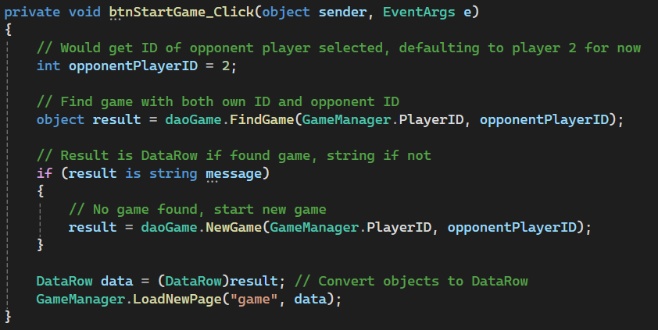

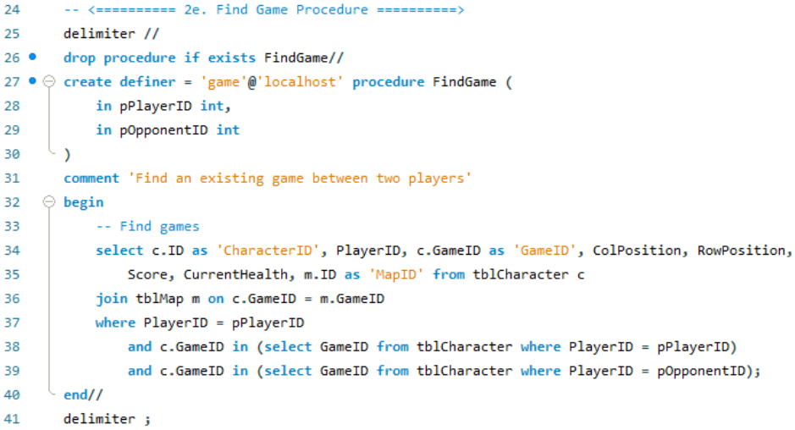

When the game screen is loaded, data is pulled from the database on the current player position and the surrounding map tiles. Every time a button is pressed, the update method is called to update the board.

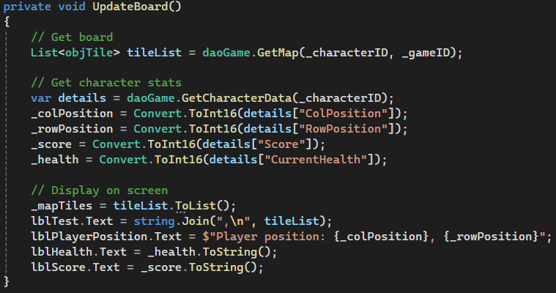

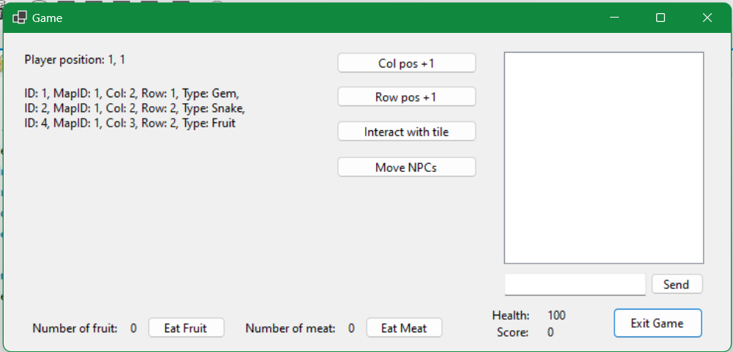

## Generate Map (Place Items) Procedure

### MySQL Procedure

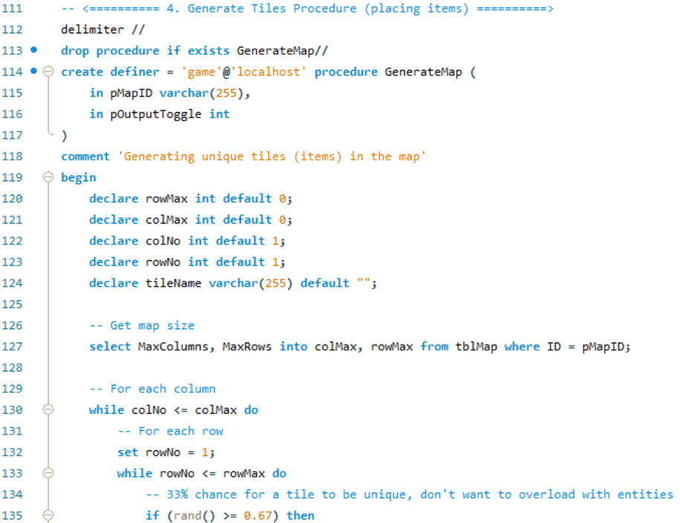

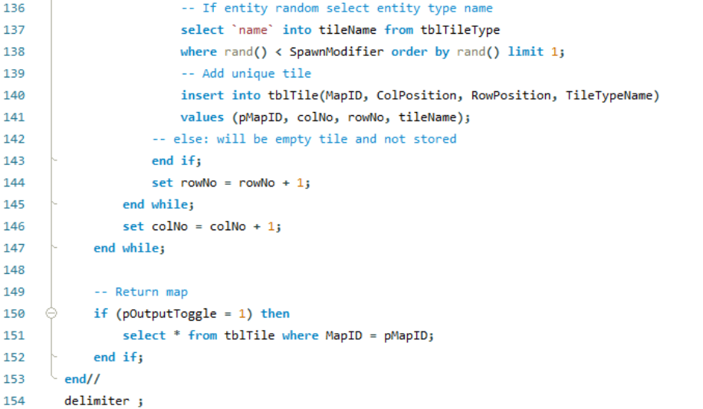



**Test Calls and Checks**

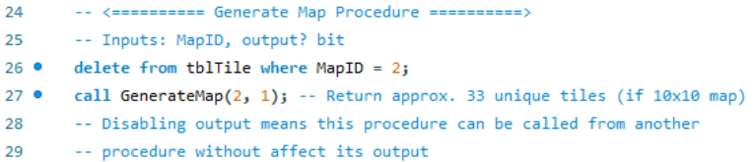

**Results**

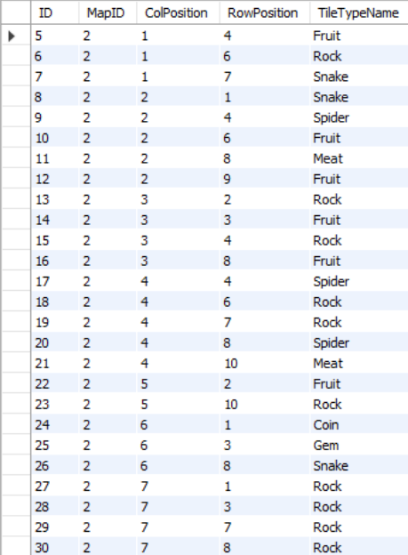 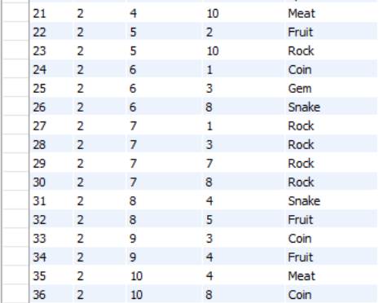

### C# Test

**DAO Method**

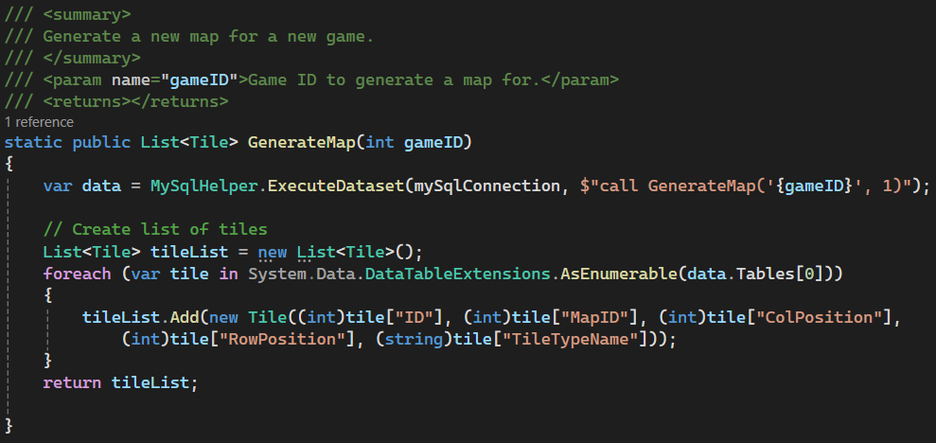

**Test Calls**

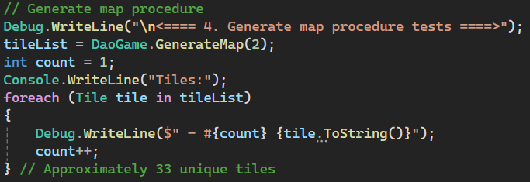

**Log Outputs** (shortened)

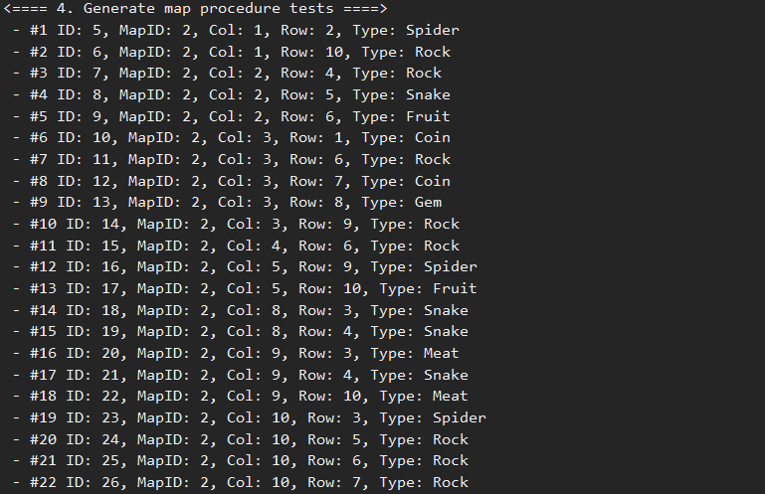

### GUI Implementation

If a game is not found between the two player ids, a new game will be made. This includes generating a new map, all of the map tiles, and new characters.



As a part of the start game procedure, it calls the generate map procedure (line 74), generating the tiles for the newly map game and map ids.

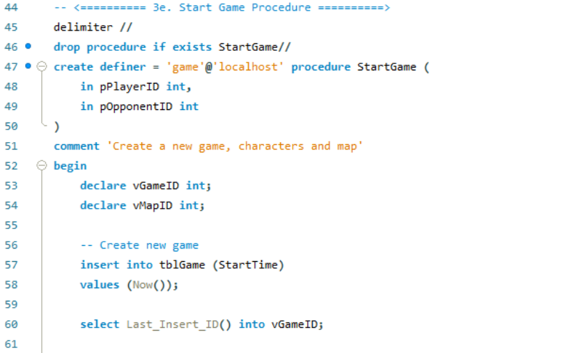

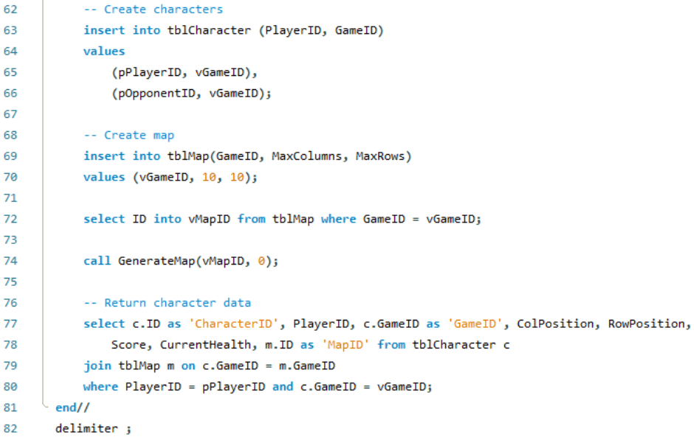

Player 3 (U: “Player3”, P: “Password123”) is not in a game, so clicking start game on their account will generate a new game.

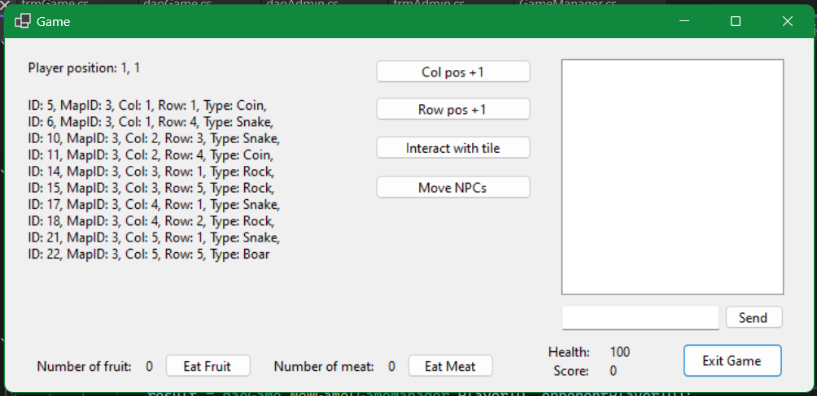

## Player Movement Procedure

### MySQL Procedure

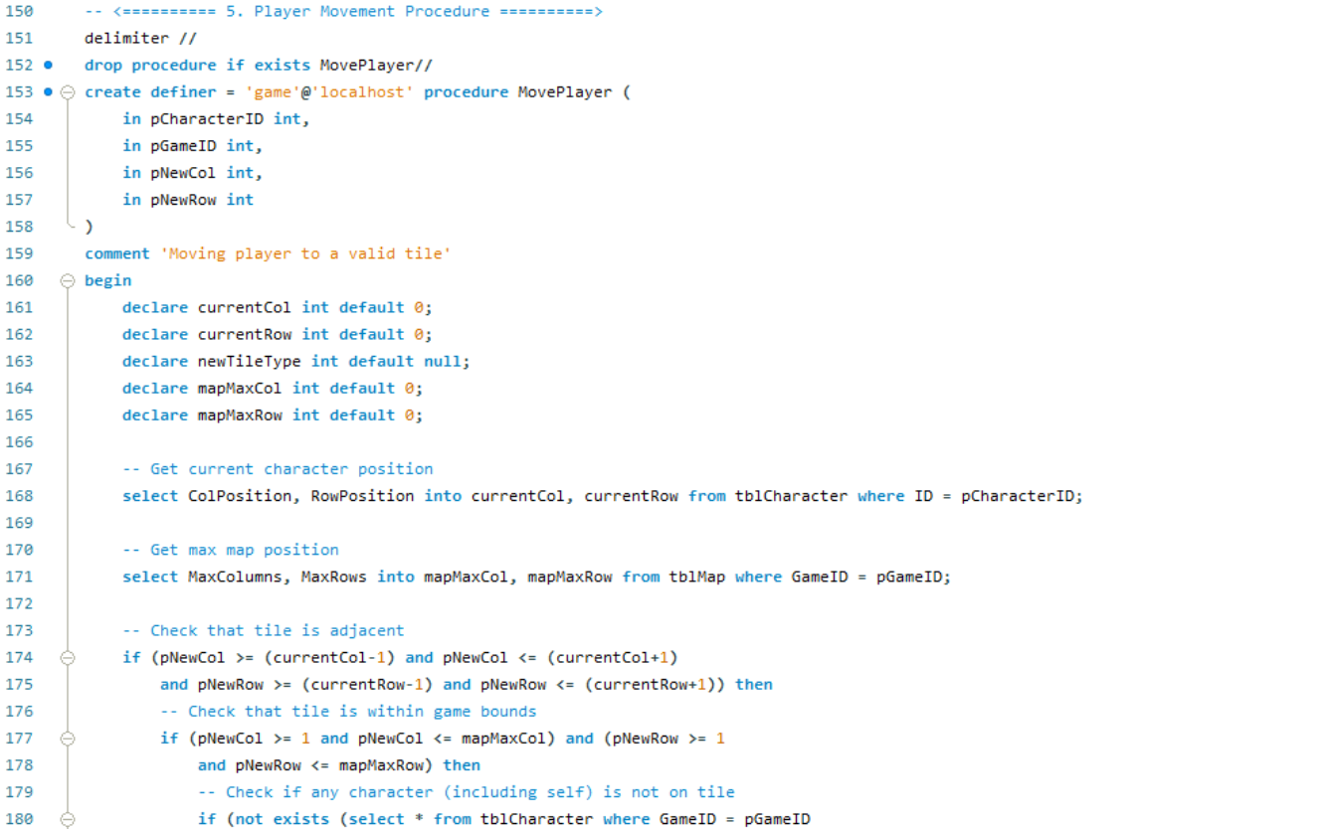

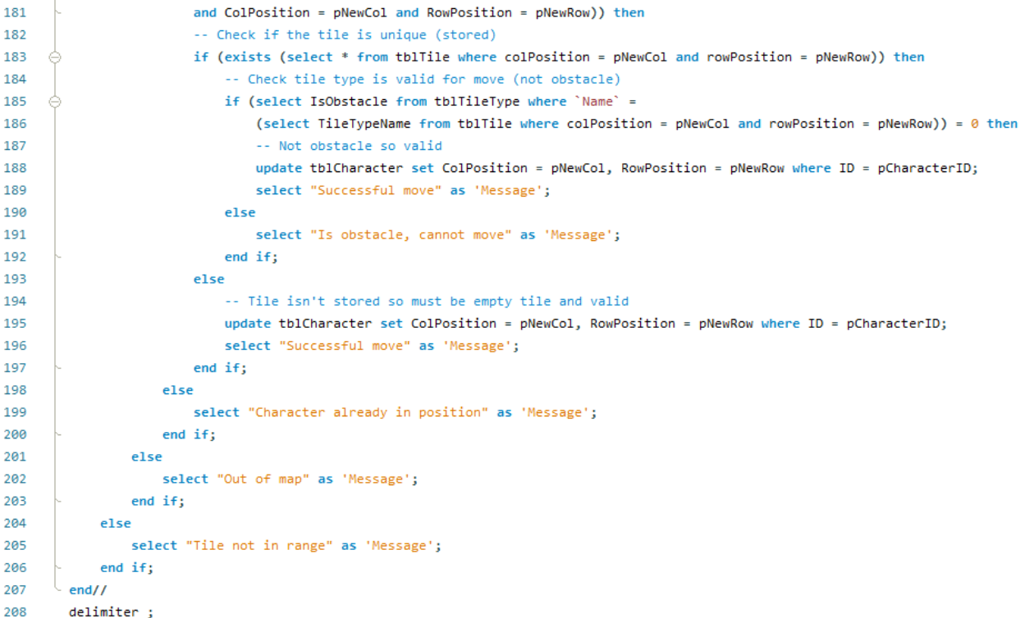

**Test Calls and Checks**

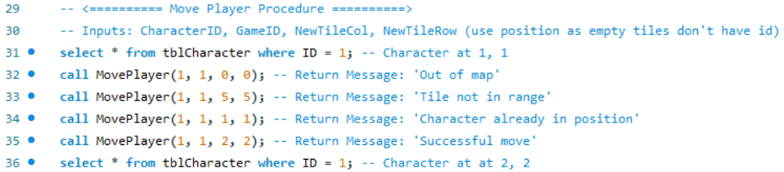

**Results**



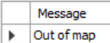 Test invalid tile

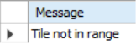 Test invalid tile

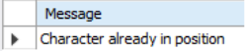 Test invalid tile

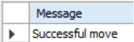 test valid tile



### C# Test

**DAO Method**

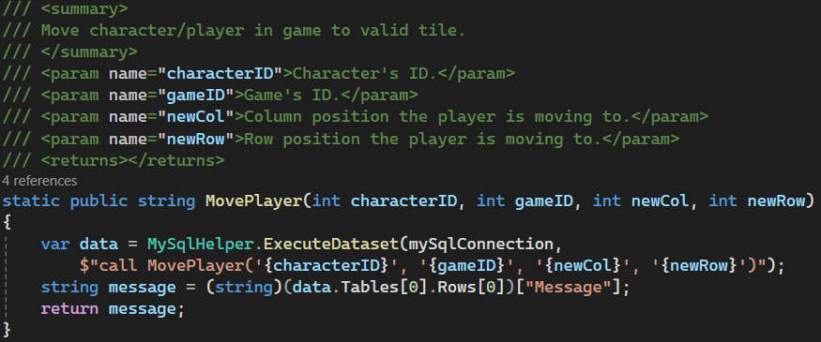

**Test Call**

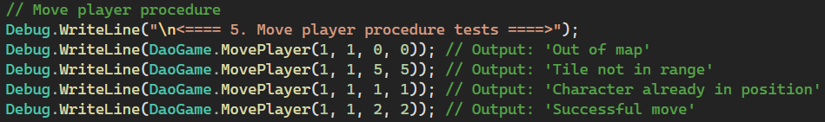

**Log Outputs**

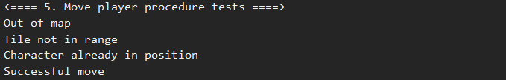

### GUI Implementation

There are currently two temporary movement methods to demonstrate the movement. One increases the column position by one, the other increases the row position by one.

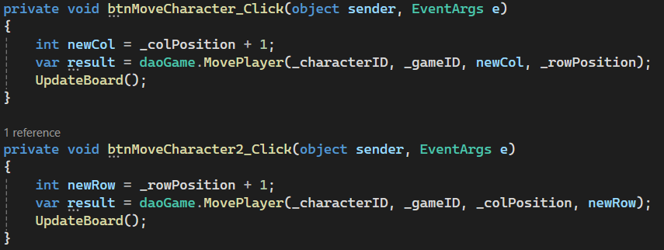

The player is at the starting tile of 1,1.

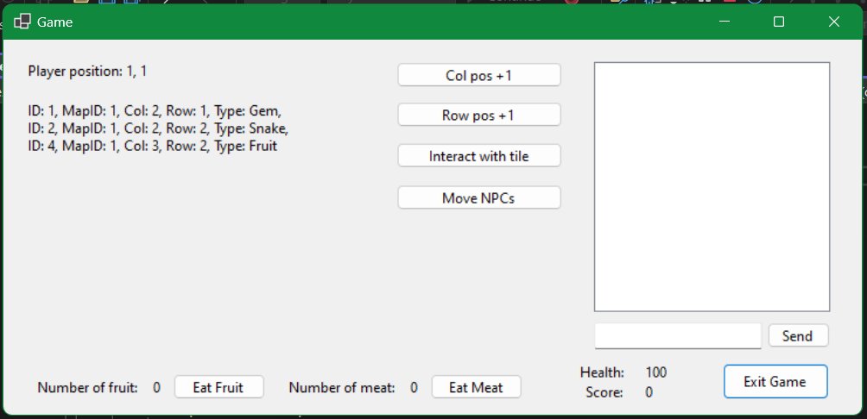

After pressing both movement buttons a few times, the player is now at 3, 2. Note that the map display has changed as more tiles are now in the view distance of 4 tiles.

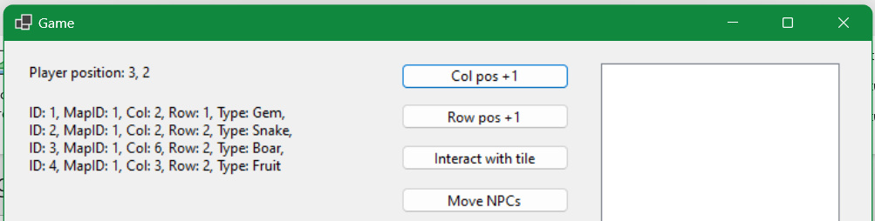

## Update Score Procedure

### MySQL Procedure

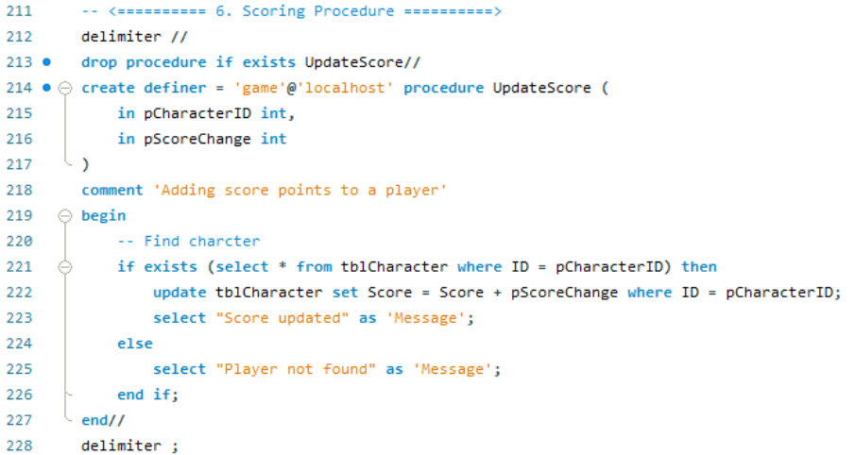

**Test Calls and Checks**

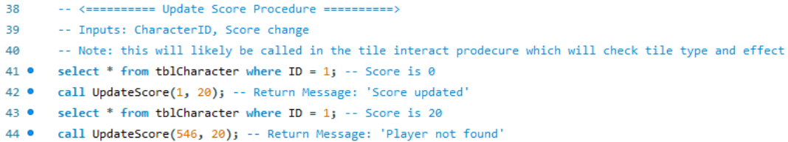

**Results**

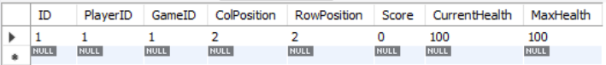

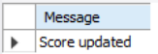Send score +20

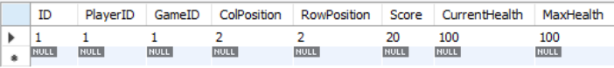

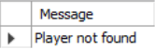 Invalid player ID

### C# Test

**DAO Method**

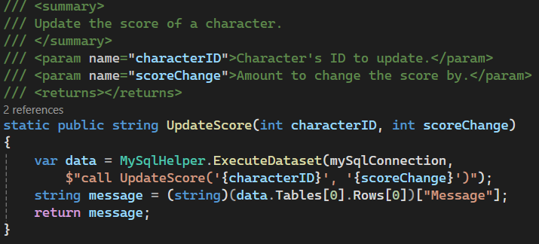

**Test Calls**

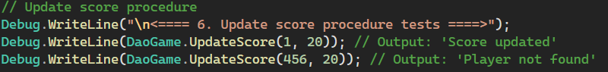

**Log Output**



### GUI Implementation

Please read the interact (pickup) procedure GUI implementation below as these are closely related with their workings and implementation.

## Interact (Pickup) Procedure

### MySQL Procedure

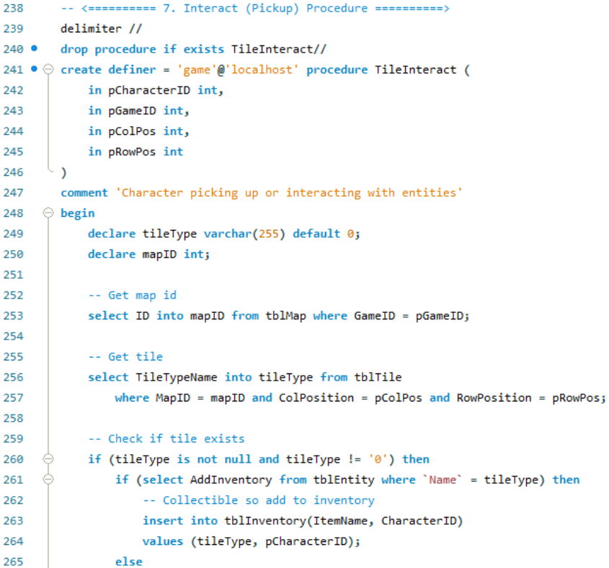

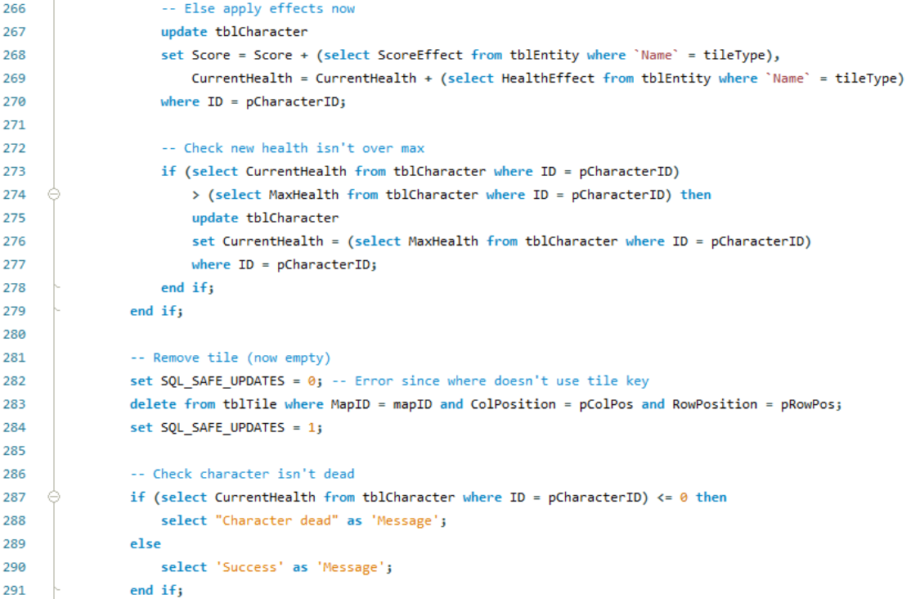



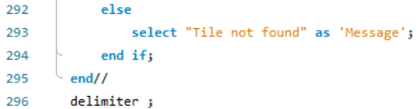

**Test Calls and Checks**

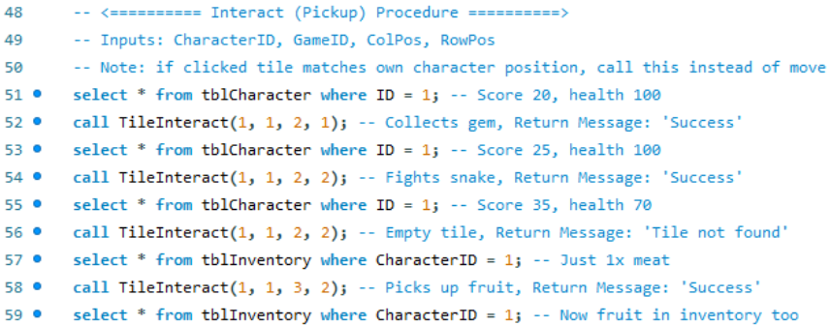

**Results**



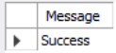 Collect gem, +5 score



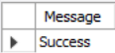 Fight snake, +10 score, -30 health



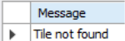 Test call invalid tile

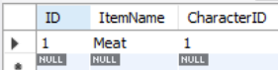 Inventory before

 Collect 1x fruit item

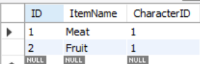 Fruit in inventory

### C# Test

**DAO Method**

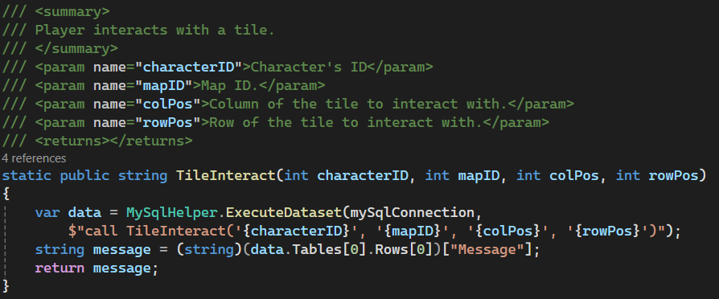

**Test Calls**

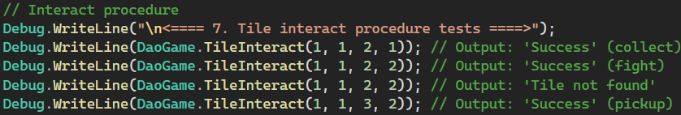

**Log Outputs**

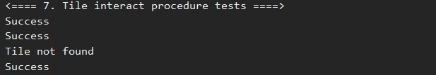

### GUI Implementation

Player is on 1,1 which contains a coin. Pressing the interact with tile button will run the interact script.

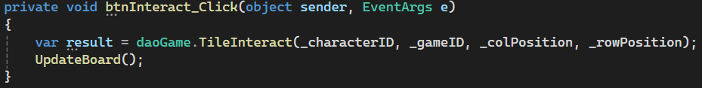

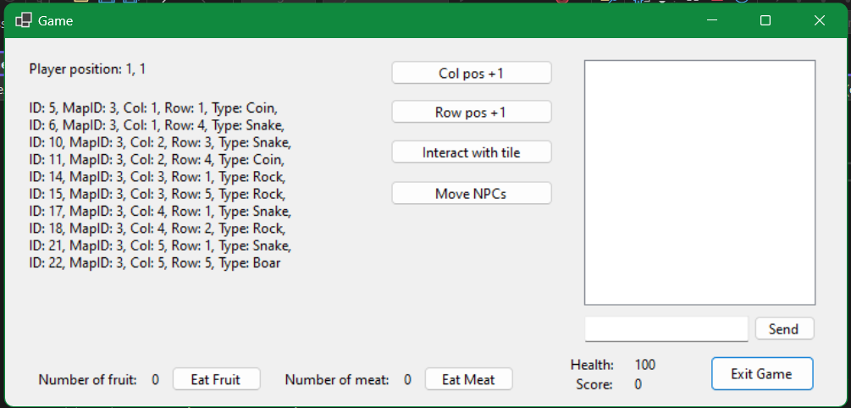

After interacting with the tile, the coin has been removed and the player’s score has increased from 0 to 1.

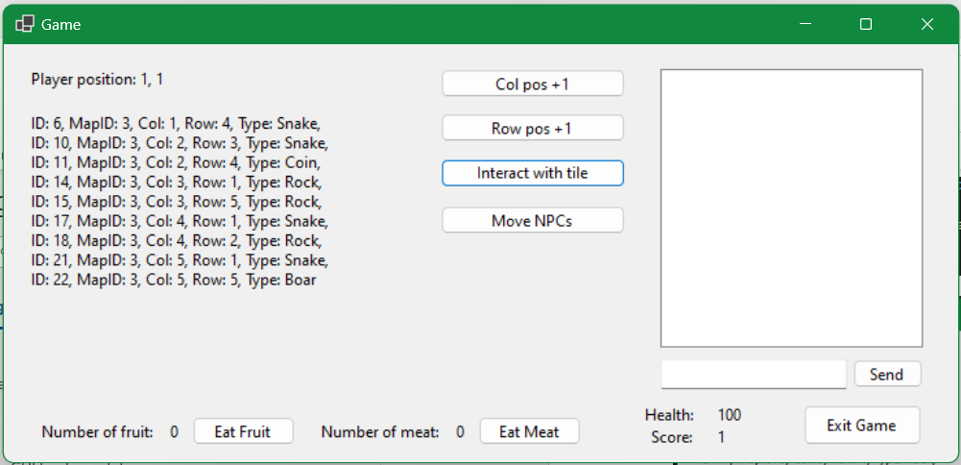

Now the player is at 1,6 over a snake.

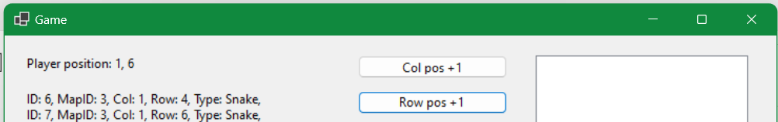

Interacting with the tile and fighting the snake will decrease the health (-30) and add score (+10).

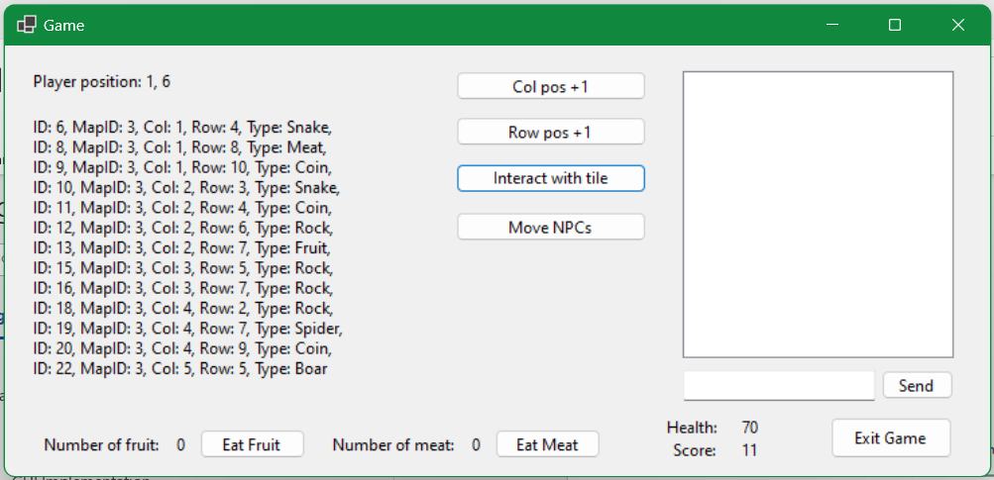

## NPC Movement Procedure

### MySQL Procedure

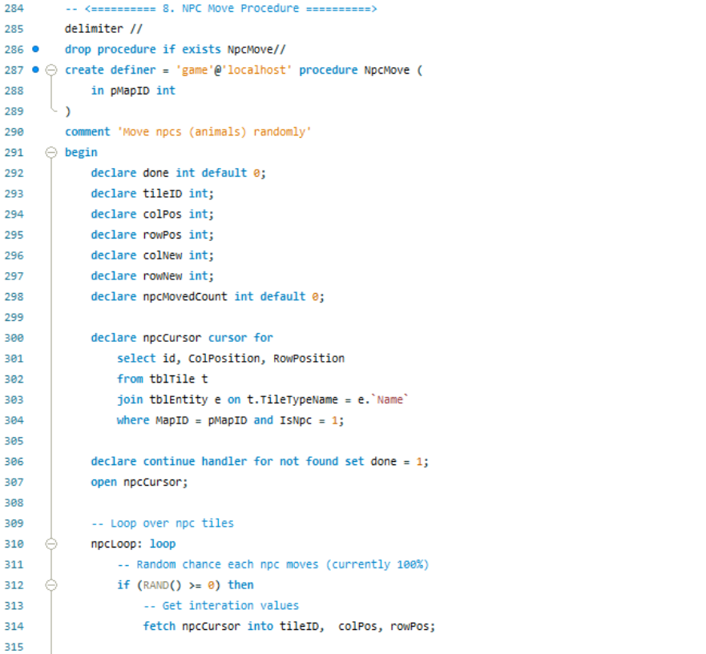



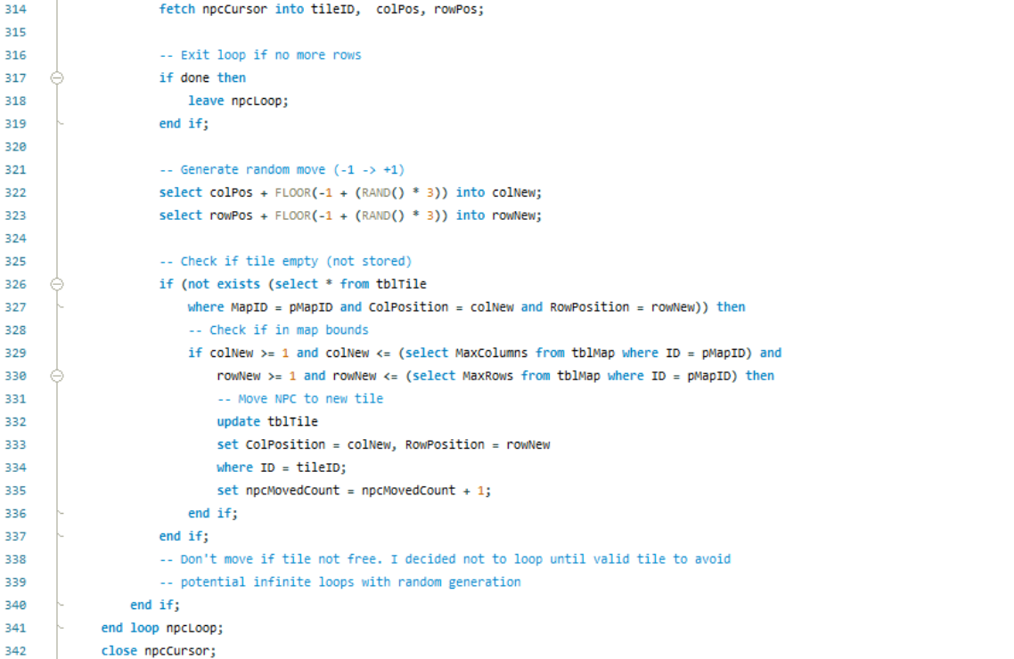

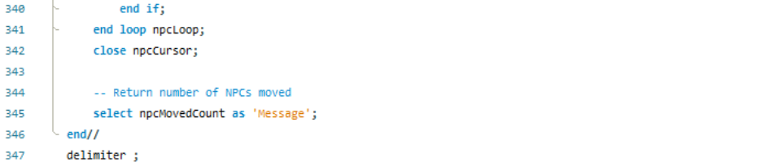

**Test Calls and Checks**

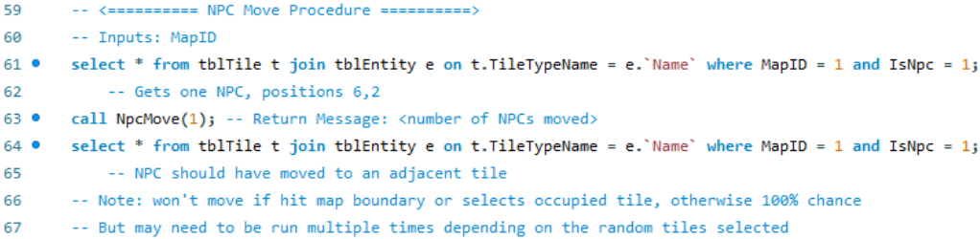

**Results**



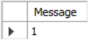 Boar moved from 6,2 -> 5,1



### C# Test

**DAO Method**

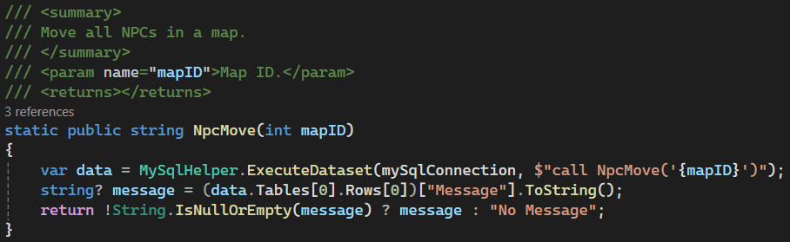

**Test Calls**

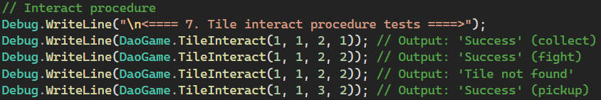

**Log Output**

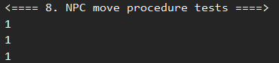

### GUI Implementation

Note how there is a snake at 1, 4 and 2, 3.

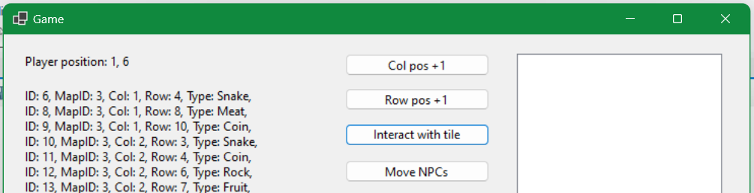

Pressing the move NPC button will run the move procedure and display a message box with the number of NPCs moved. Note, NPCs will not always move if the random new position is already a unique tile.

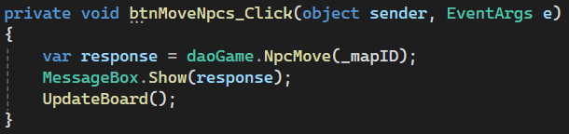

Note the snakes are now at 2, 3 and 5, 4.

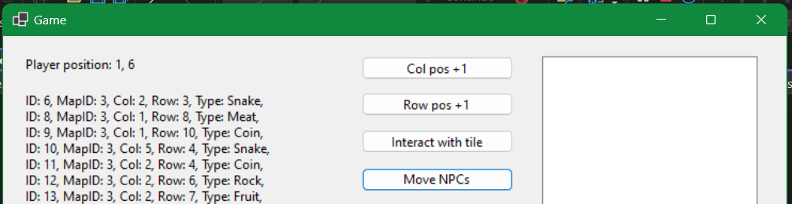 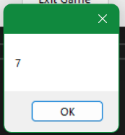

## Stop Game Procedure

### MySQL Procedure

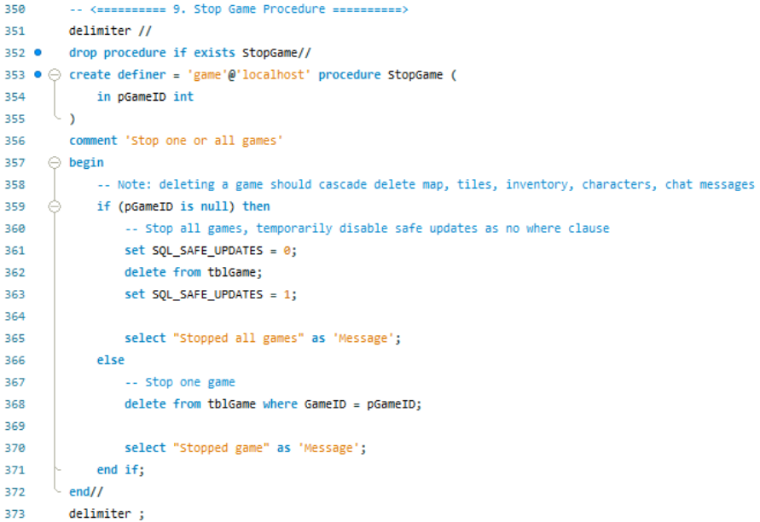

**Test Calls and Checks**

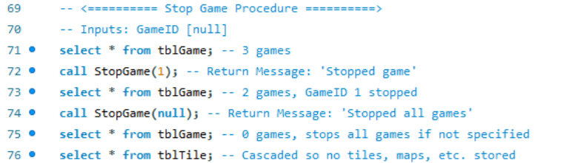

**Results**

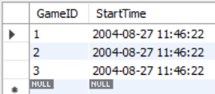 Starts with 3 games

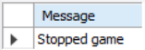 First call stops game 1

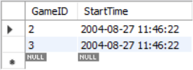 GameID 1 gone

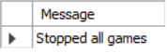 Second call stops all remaining games

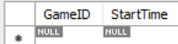 No games

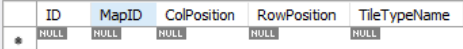 Cascade deletes tiles, etc.

### C# Test

**DAO Methods**

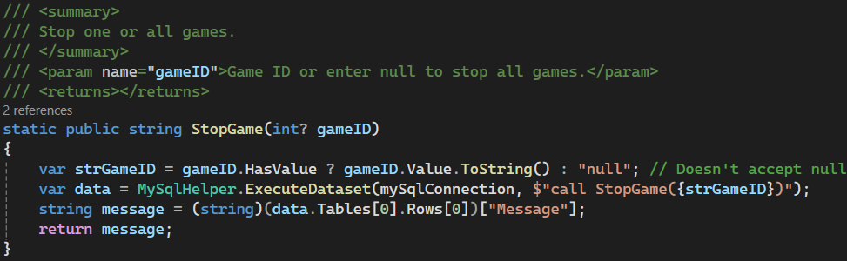

**Test Calls**

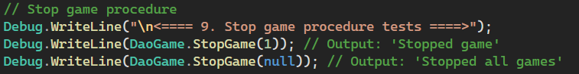

**Log Outputs**

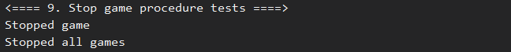

### GUI Implementation

From the lobby, clicking the admin button will load the admin screen. This screen shows the online players and games.

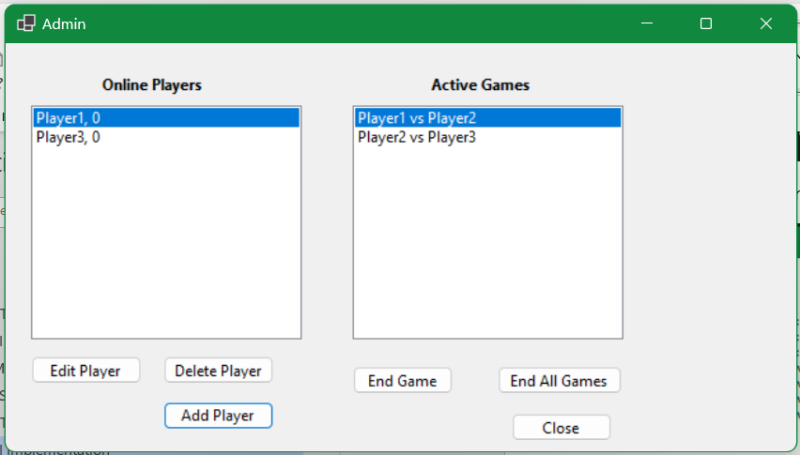

Selecting a game and clicking end game will end that game, cascade deleting all data from the database. Clicking end all games will end all games.

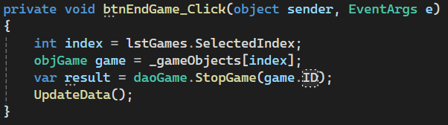

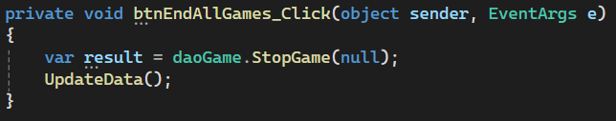

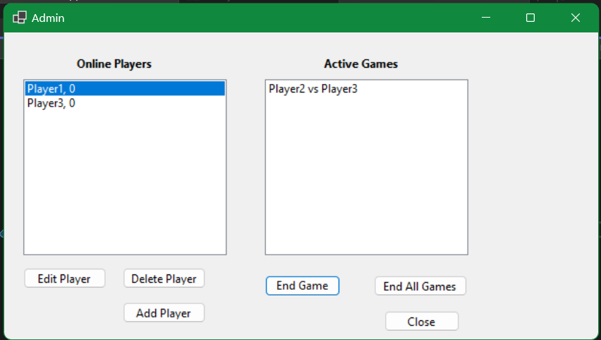

## New Player Procedure

### MySQL Procedure

This procedure uses the same MySQL procedure as the player register. Please refer to the register procedure section.

### C# Test

This procedure uses the same MySQL procedure as the player register. Please refer to the register procedure section.

### GUI Implementation

Player list before. Note 4 players.

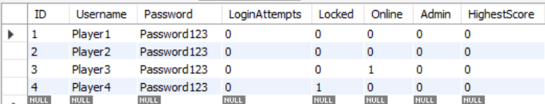

From the admin view, the user can press the add player button, which will create a new example user account. This will eventually have a form tied to it.

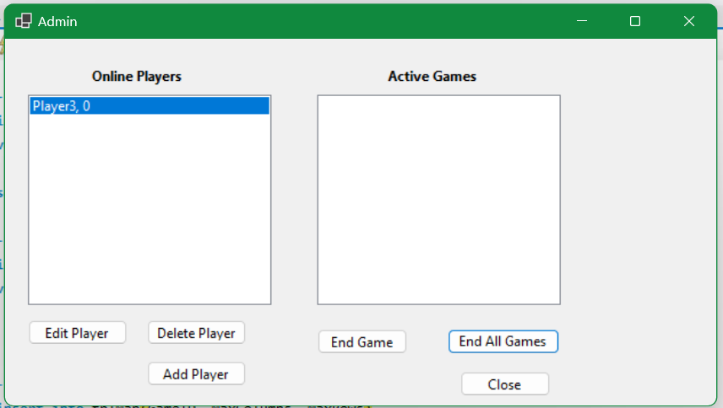

Clicking add player has added a new account (U: “MegaX”, P: “Password123”). A popup confirms that the account is created. Note however that while the player account has been created, it is not logged into, so it is offline and will not show up in the active player list.

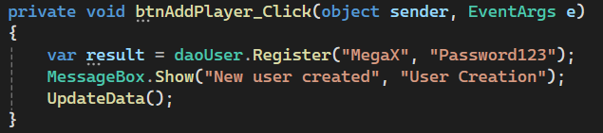 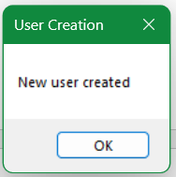

New account is in the database.

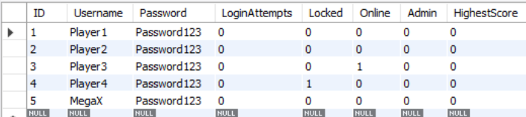

## Update Player Procedure

### MySQL Procedure

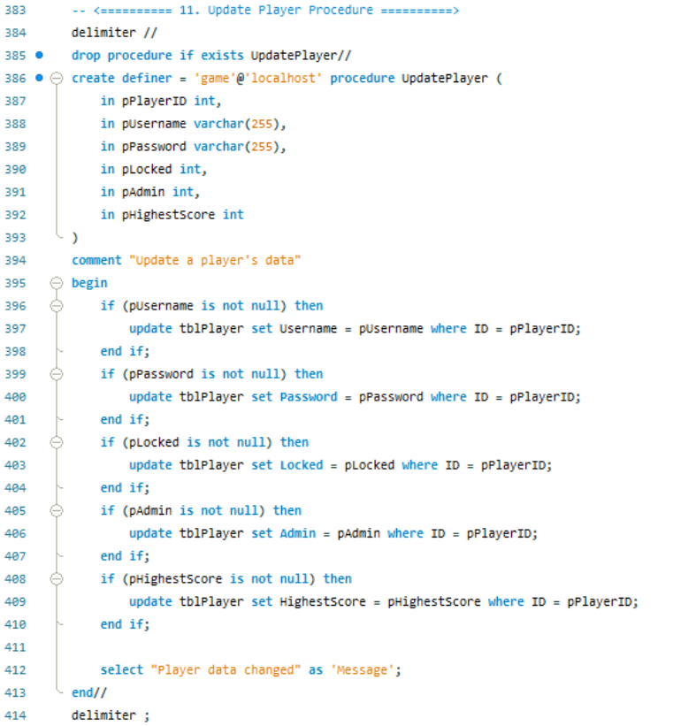

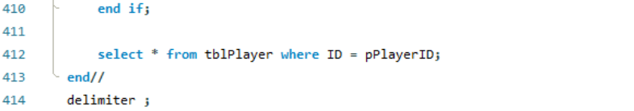

**Test Calls and Checks**

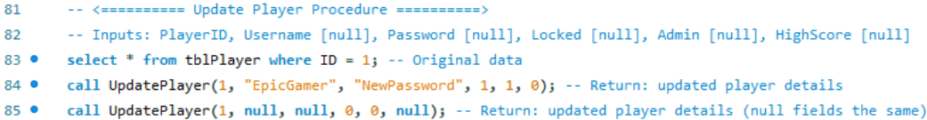

**Results**

 Before

 Full change

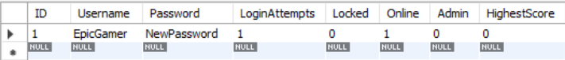 With nulls

### C# Test

**DAO Method**

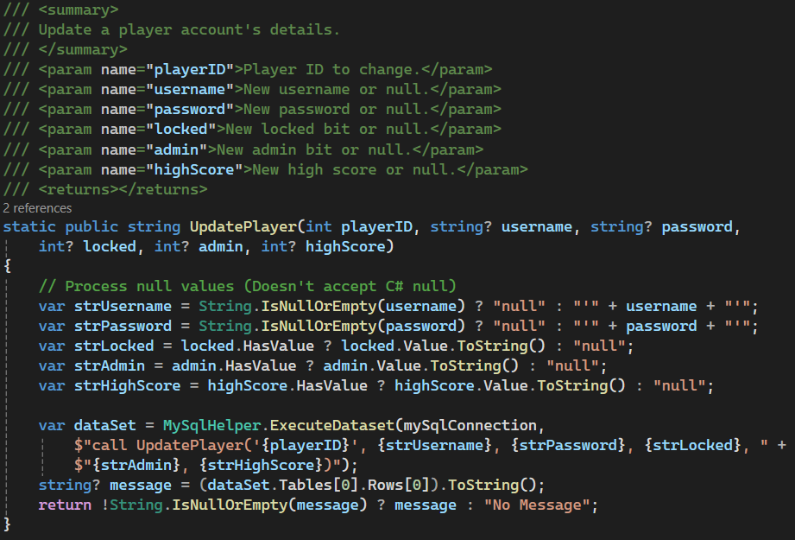

**Test Calls**



**Log Outputs**

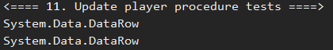

### GUI Implementation

When a user clicks the edit player button, player 1’s username will be updated. This is current set to always change player 1’s id as an example but will be integrated with an update details form in account management.

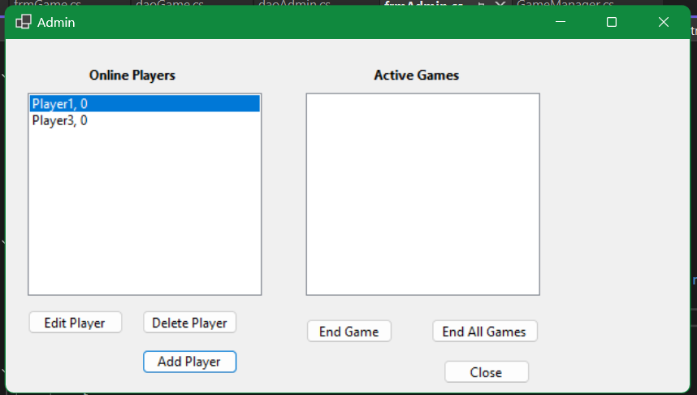

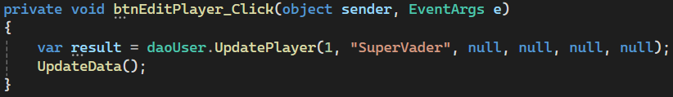

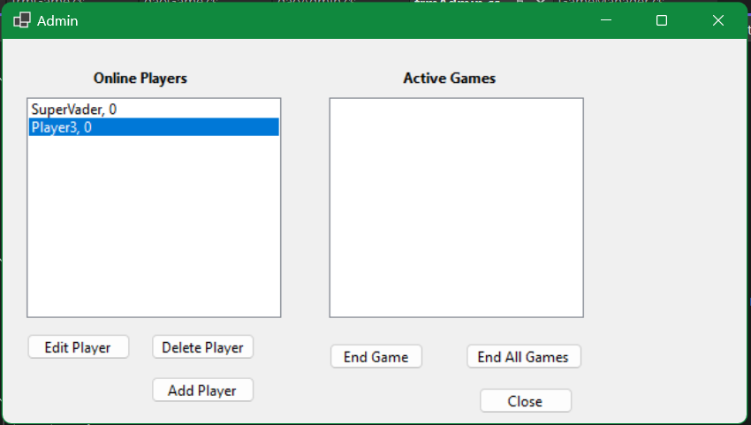

## Delete Player Procedure

### MySQL Procedure

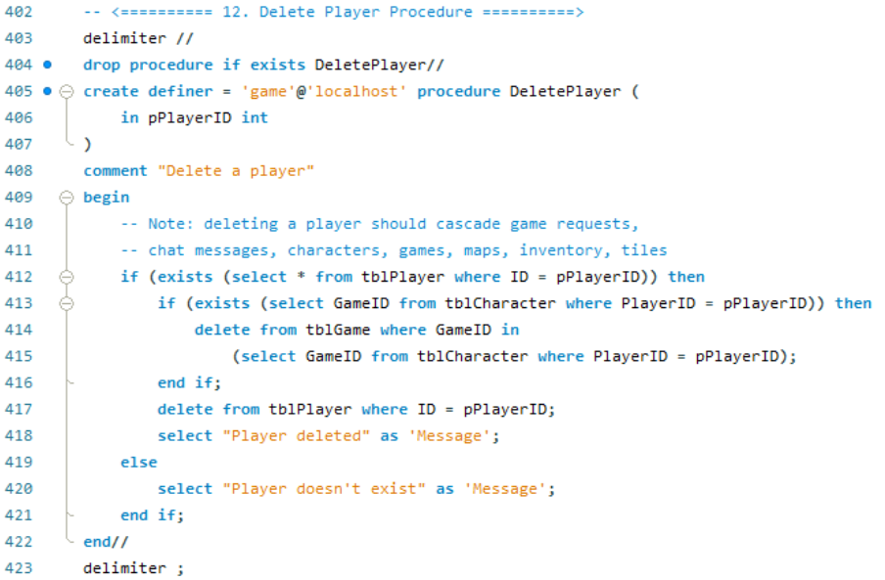

**Test Calls and Checks**

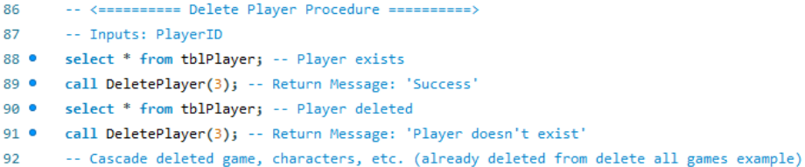

**Results**

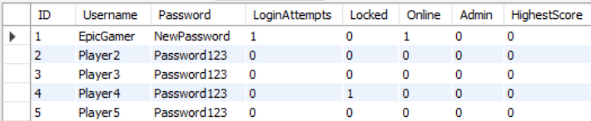 Before

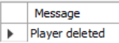 Delete Player 3

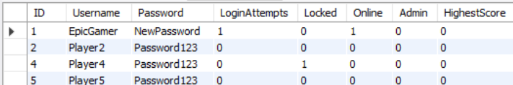 After

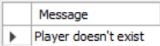 Deleting invalid player id

### C# Test

**DAO Methods**

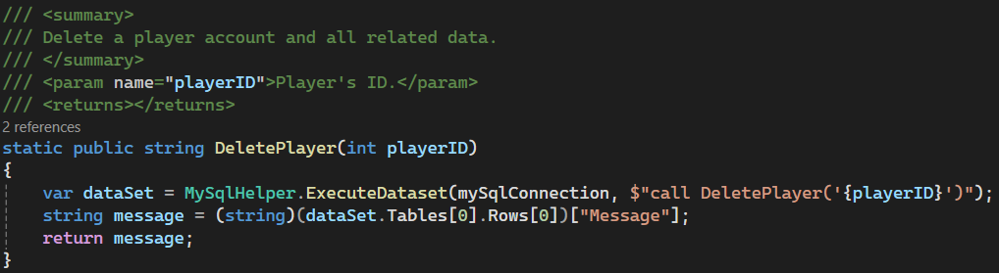

**Test Calls**

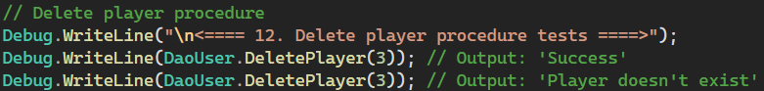

**Log Outputs**

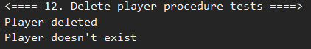

### GUI Implementation

By selecting an online player, and clicking delete player, the user can delete player accounts. This will cascade delete any characters, games, maps, tiles, inventories, etc.

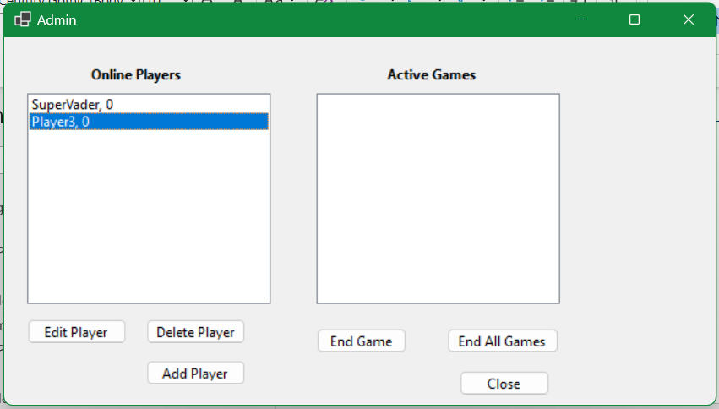

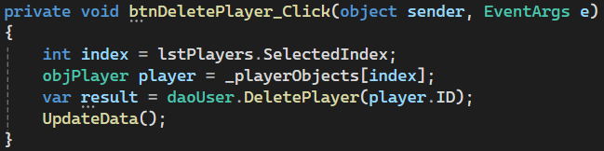

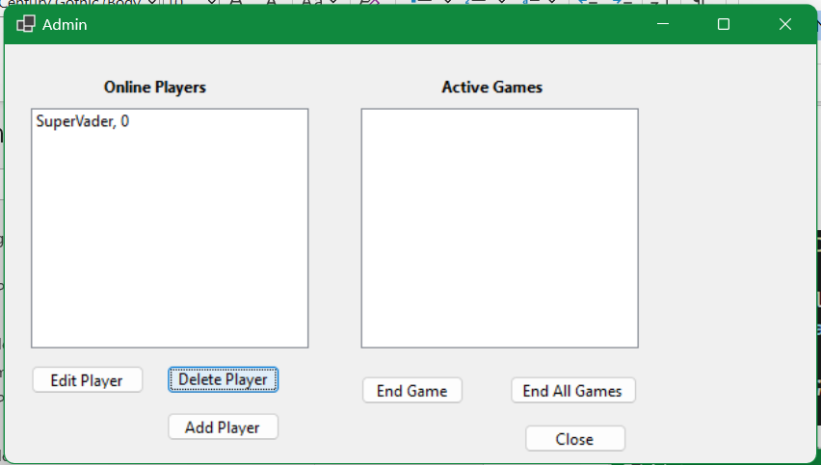

# Multiuser Concurrency (Milestone 3)

## Concurrency Refactoring

### Procedure Level

My existing procedure file (/db/procedures.sql) has been updated with transaction management and error handling. The same test data from the previous test file (/db/procedure_tests.sql) are compatible.

### Session Level

As well as adding transaction management to handle concurrency with multiple users, I also changed the session isolation level. The default repeatable read is a good general isolation level that creates a snapshot when the first select is run, meaning all following selects in the transaction will have consistent results. I have decided to change my database to use read committed instead. This offers slightly less data consistency for more performance as snapshots are no longer being created and less locking overhead is performed. I have decided to make this change because data consistency is not as important in the game scenario. For applications like a bank, data consistency is absolutely vital, however in the game it is less important to maintain data consistency as the consequences are much more minor and the game is constantly updating states anyway so the change will be read on the next loop. With many users, there will be a huge number of procedures and queries being run every second so the trade-off for higher performance allowing for more players and faster running games is worthwhile. Read committed provides a good balance of maintaining data consistency while providing a higher level of performance (PingCAP Team, 2024; MySQL, n.d.).

I decided to implement this through a setup procedure which is called when the database connection is established. In the base DAO, the setup procedure is called which sets the transaction isolation level for the session.

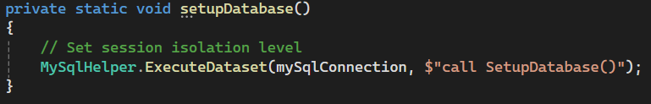

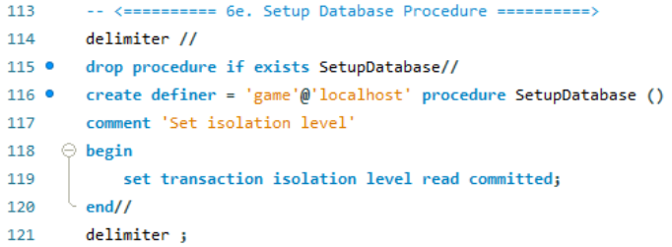

## Error & Exception Handling

### Procedure Changes

I have updated all of the key DAO methods to include error and exception handling. I have done this in two ways:

1. Using a try catch to catch and display any errors. Any errors that occur in the try block (e.g. database returns and error or incorrect data that can’t be handled), will display a message box with the error and return placeholder data back to the program.
2. If the database returns an error message (starts with “Error”), then manually throw an exception with the returned message.

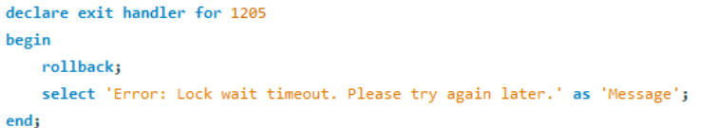

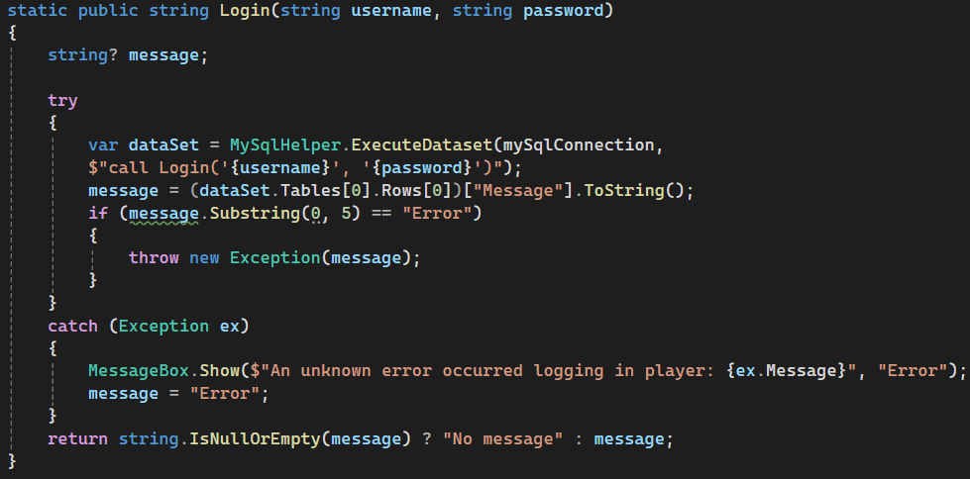

### Tests

Note: all of my key DAO methods have C# error handling, however some are impossible to purposefully cause errors to demonstrate. I have included testing screenshots for only those I could purposefully cause errors to test. All of my procedures have internal error handling which handles almost every expected boundary value or unexpected input making it hard to return an error.

There were two main ways I demonstrated the error handling:

1. By performing an SQL injection on string inputs, the procedure would fail and return an error, which would be handled in the DAO method.
2. Some integer-only inputs would allow values outside of the expected input (e.g. -1) which would return an error.

**Login**

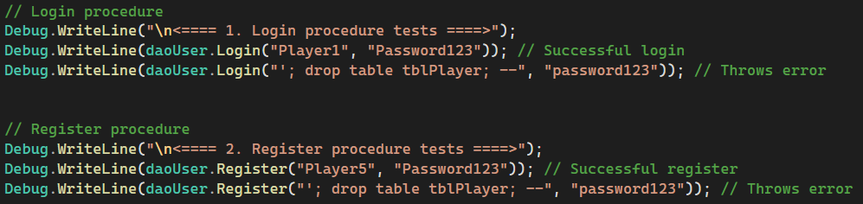

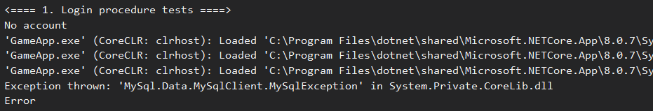

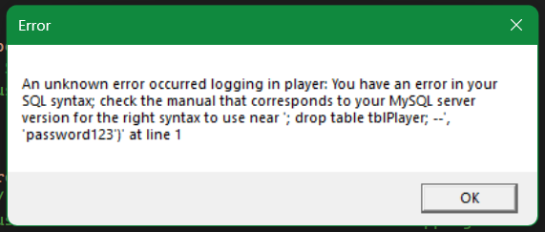

**Register**





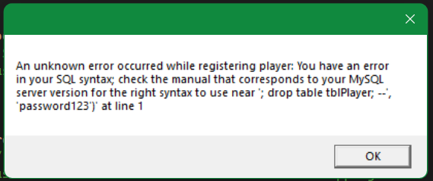

**Generate Map**

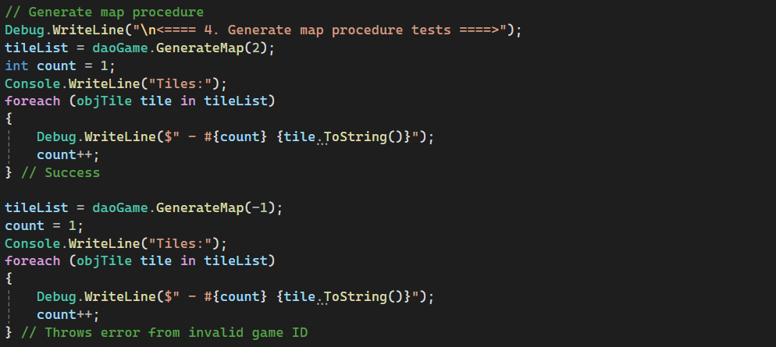

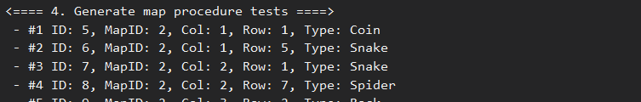

(Shortened)



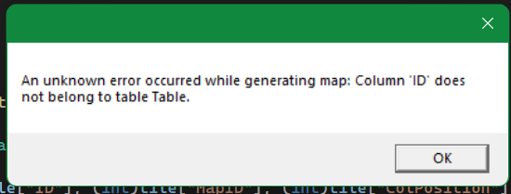

**Interact**

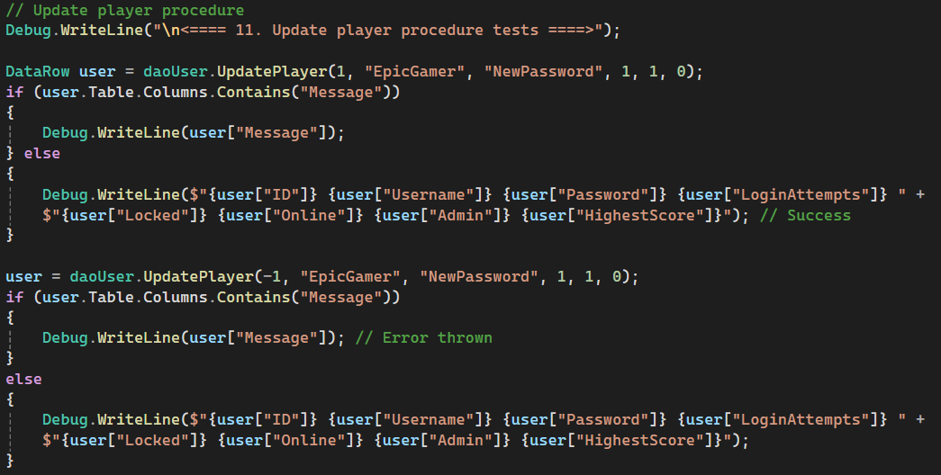

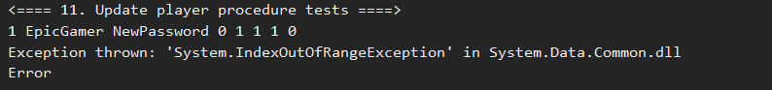

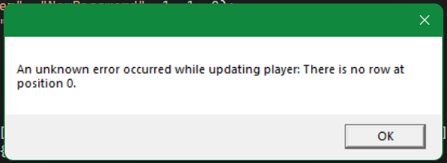

## Concurrency Management Comparison

**MySQL Concurrency**

Concurrency in MySQL procedures is mainly managed through the locking of tables and rows to avoid inconsistent results and data integrity issues. This is done by default in MySQL based on what isolation level is set. There are four isolation levels:

1. Read uncommitted: select statements are able to read uncommitted changes from other transactions.
2. Read committed: select statements are not able to read uncommitted changes from other transactions but can read any newly committed values.
3. Repeatable read: select statements read a snapshot made when starting the transaction, so the read is always repeatable for consistency.
4. Serializable: this mode creates shared locks on all select statements, meaning those rows cannot be modified until the original transaction is complete. This uses much more locking, impacting performance but ensure the highest level of integrity and consistency.

(MySQL, n.d.)

In my project, I have set the isolation level to read committed



Isolation levels are used with transactions. Transactions encapsulate SQL statements and allow for stronger management of error handling and concurrency. A transaction can perform many SQL statements then either commit them to the database or rollback to the original state. This means all changes during the transaction can be committed at once, or if something goes wrong, the changes can be reversed (MySQL, n.d.). This relates to isolation levels because uncommitted read can read any uncommitted changes, whereas the other levels cannot.

The combination of isolation levels and transactions enforces the ACID properties on the database. ACID stands for atomicity, consistency, isolation, and durability. Atomicity refers to all changes being treated as a single group of changes, meaning either all succeed, or none succeed. This is achieved through the use of transactions committing all changes at the end of rolling back if an error occurs. Isolation is the ability for multiple transactions to execute without interfering, which is managed through the isolation levels. As discussed, the different isolation levels determine how transactions interact with the database and each other to ensure that data is handled as intended for the needs of the database. Consistency refers to keeping the data in a valid and consistent state and durability relates to making data changes permanent, which relate less to concurrency (Bukar, 2023).

The following example shows two examples of a transaction with simple statements. The first commits both statement changes together treating them atomically, and the second demonstrates making data changes and rolling back to the original values.

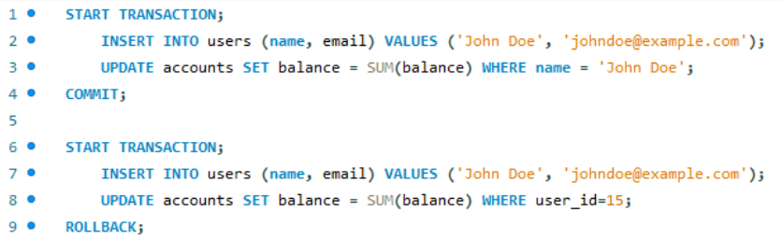

(Bukar, 2023)

**.Net Concurrency**

C# .Net includes a similar concept of transactions for performing operations. By using the TransactionScope class, operations can be encased in the code block to be performed, then either committed atomically with scope.Complete() or automatically rolled back if the block is finished without commit or an exception is thrown. The following example encapsulates the creation and execution of two SQL queries in a transaction scope, committing the changes together at the end (Microsoft, n.d.).

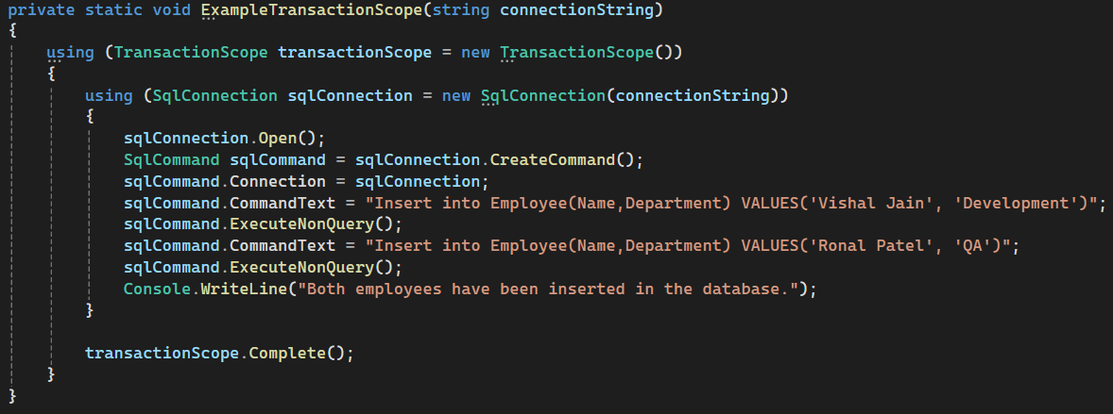

(Shah, 2023)

C# .Net also provides Entity Framework, an object-relational mapper for working with relational data through domain specific classes. Users can create a class to represent each of the tables in the database and use the DbContext class to represent the database as a whole. The entity framework allows for interacting with the data at a higher level of abstraction in C# instead of in the database engine directly. This allows for performing database operations in conjunction with C# .Net transactions (discussed above) and other C# controls. Entity Framework also uses optimistic concurrency by default to protect from overwriting changes made by other users since fetching data (Andrade, 2023; Entity Framework Tutorial, n.d.).

Another option for database connections in C# .Net is LINQ to SQL, which maps the data model of a relational database to an object model in C#. During application execution, queries from the object model are translated into SQL and executed in the database. Results are automatically converted back into objects for handling in C# (Microsoft, 2021). The below example creates a LINQ query to select the company name of customers based in London. The query is stored in a variable and ran as the results are called, allowing the results to be iterated over and displayed.

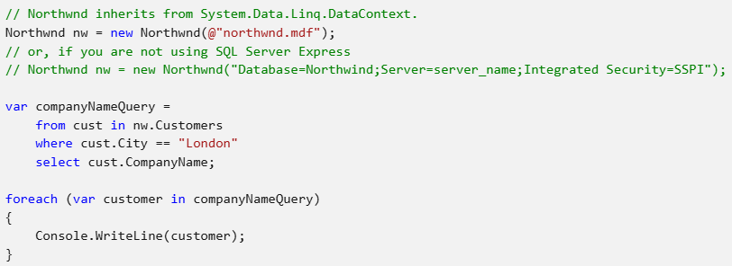

(Microsoft, 2021)

**Comparison**

In addition to the obvious differences of handling querying and data processing in different system, MySQL and Entity Framework take quite different approaches to concurrency management. Entity Framework uses an optimistic approach, which assumes infrequent transaction conflicts and allows transactions to occur asynchronously without interference. If any conflicts are identified when committing changes, a user will have to manually interfere and complete the transactions. This approach allows easier application scaling as multiple users can be served at once and has no performance impact. MySQL however supports both optimistic and pessimistic concurrency management. Pessimistic concurrency is managed through locks, which restrict certain actions on records when other actions occur. It assumes frequent conflicts been transactions, and uses locks to prevent other users from updating data that is being used in another transaction. This can be done in varying levels of restriction to balance data consistency and performance, covered in the four isolation levels in the MySQL section (Dulanga, 2022). The best approach is determined by the needs of the system and the purpose of the application.

## Changes

Please note that I have made some changes to the milestone 1 section of my report to fill any areas I did not cover fully. These changes and improvements are in red.

# References

Andrade, L. (2023, October 21). *Step-by-Step Guide to Entity Framework in .NET.* Retrieved from Medium: https://medium.com/@lucas.and227/step-by-step-guide-to-entity-framework-in-net-c629faf9f322

Bukar, A. (2023, February 10). *How to Use MySQL Transactions.* Retrieved from Free Code Camp: https://www.freecodecamp.org/news/how-to-use-mysql-transactions/

Dulanga, C. (2022, July 26). *Optimistic vs Pessimistic Concurrency: What Every Developer Should Know.* Retrieved from Cult by Honypot: https://cult.honeypot.io/reads/optimistic-vs-pessimistic-concurrency/

Entity Framework Tutorial. (n.d.). *What is Entity Framework?* Retrieved from https://www.entityframeworktutorial.net/entityframework6/what-is-entityframework.aspx

Microsoft. (2021, September 15). *Getting Started.* Retrieved from https://learn.microsoft.com/en-us/dotnet/framework/data/adonet/sql/linq/getting-started

Microsoft. (2021, September 15). *LINQ to SQL.* Retrieved from https://learn.microsoft.com/en-us/dotnet/framework/data/adonet/sql/linq/

Microsoft. (n.d.). *TransactionScope Class.* Retrieved from https://learn.microsoft.com/en-us/dotnet/api/system.transactions.transactionscope?view=net-8.0

MySQL. (n.d.). *15.3.1 START TRANSACTION, COMMIT, and ROLLBACK Statements.* Retrieved from https://dev.mysql.com/doc/refman/8.4/en/commit.html

MySQL. (n.d.). *17.7.2.1 Transaction Isolation Levels.* Retrieved from https://dev.mysql.com/doc/refman/8.4/en/innodb-transaction-isolation-levels.html

MySQL. (n.d.). *17.7.2.1 Transaction Isolation Levels.* Retrieved from https://dev.mysql.com/doc/refman/8.4/en/innodb-transaction-isolation-levels.html

PingCAP Team. (2024, July 17). *Exploring Read Committed and Repeatable Read Isolation Levels.* Retrieved from TiDB: https://www.pingcap.com/article/exploring-read-committed-and-repeatable-read-isolation-levels/#Read_Committed_vs_Repeatable_Read

Shah, V. (2023, May 5). *TransactionScope in C#.* Retrieved from TatvaSoft: https://www.tatvasoft.com/blog/transactionscope-in-c/